Serious Game Framework for Mental Health

Tehreem Shabbir
17i-1076

Master of Science Software Engineering


Department of Computer Science
National University of Computer & Emerging Sciences Islamabad, Pakistan.

2019

i

Developing Serious Game Framework for Mental Health
Submitted by
Tehreem Shabbir
17i-1076

Supervised by
Dr. Arshad Ali Shahid

Master of Science Software Engineering
A thesis submitted in partial fulfillment of the requirements for the degree of Master of Science (Computer Science) at National University of Computer & Emerging Sciences

Department of Computer Science
National University of Computer & Emerging Sciences Islamabad, Pakistan.
30-12-2019

ii

Certificate of Approval


It is certified that the research work presented in this thesis, entitled “Developing Serious Game Framework for Mental Health” was conducted by Tehreem Shabbir under the supervision of Dr. Arshad Ali Shahid.

No part of this thesis has been submitted anywhere else for any other degree.

This thesis is submitted to the Department of Computer Science in partial fulfillment of The requirements for the degree of Masters of Science in Software Engineering
At the
National University of Computer and Emerging Sciences, Islamabad, Pakistan December’ 2019

Candidate Name: Tehreem Shabbir Signature:
Supervisor: Dr.Arshad Ali Shahid Signature:
Examination Committee:
- Name: Dr. Amna Basharat Signature: Assistant Professor, FAST-NU Islamabad.

- Name: Omer Baig Signature: Assistant Professor, FAST-NU Islamabad.

Dr. Waseem Shehzad Signature: Graduate Program Coordinator,
National University of Computer and Emerging Sciences, Islamabad, Pakistan.

Plagiarism Undertaking
I take full responsibility of the research work conducted during the MS Thesis titled “Developing Serious Game Framework for Mental Health”. I solemnly declare that the research work presented in the thesis is done solely by me with no significant help from any other person; however, small help wherever taken is duly acknowledged. I have also written the complete thesis by myself. Moreover, I have not presented this thesis (or substantially similar research work) or any part of the thesis previously to any other degree awarding institution within Pakistan or abroad.
I understand that the management of Department of Computer Science of National University of Computer and Emerging Sciences has a zero-tolerance policy towards plagiarism. Therefore, I as an author of the above-mentioned thesis, solemnly declare that no portion of my thesis has been plagiarized and any material used in the Thesis from other sources is properly referenced. Moreover, the thesis does not contain any literal citing of more than 70 words (total) even by giving a reference unless I have the written permission of the publisher to do so. Furthermore, the work presented in the thesis is my own original work and I have positively cited the related work of the other researchers by clearly differentiating my work from their relevant work.
I further understand that if I am found guilty of any form of plagiarism in my thesis work even after my graduation, the University reserves the right to revoke my MS degree. Moreover, the University will also have the right to publish my name on its website that keeps a record of the students who plagiarized in their thesis work.

Tehreem Shabbir Dated: 30th December 2019

Author’s Declaration

I, Tehreem Shabbir, hereby state that my MS thesis titled “Serious Game Framework for Mental Health” is my own work and it has not been previously submitted by me for taking partial or full credit for the award of any degree at this University or anywhere else in the world. If my statement is found to be incorrect, at any time even after my graduation, the University has the right to revoke my MS degree.

Tehreem Shabbir Date: 30 December 2019

Abstract
The modern trend of Serious gaming has started to get popular, it is being used in many other fields of education, simulation, military, political and HR to improve the productivity of users and engage them more in their tasks, it is assumed that serious games can be used in mental health care, which can help to overcome issues like stress, to enhance well-being and in making positive behavioral changes. In our study Game elements and psychological interventions have been identified from the literature, and then mapping has been done. A serious game framework has been proposed to guide developers to develop serious games for mental health domain, games that address mental health disorders with treatments modelled on them. An expert validation has been done on framework, which is later implemented on a game, SyncEscape, which is a serious game with an aim to address stress. Controlled Experiment was conducted, which showed positive results that game implemented with game design factors reduces stress.

Acknowledgements
First of all, I am obliged to Allah Almighty the Merciful, the Beneficent and the source of all Knowledge, for granting me the courage and knowledge for this thesis. I am grateful to my thesis supervisor and mentor Sir Arshad Ali Shahid, who has guided and encouraged me throughout the thesis. I am also thankful to my parents and brothers. Their unlimited support and trust in me made my goal achievable.

Table of Contents

Chapter 1: Introduction 12
  - Background 12
  - Problem Statement 13
  - Goals and Objectives 14
  - Summary of this chapter 14
Chapter 2: Literature Review 15
  - Literature on Game Design 15
  - Literature Review on Game Factors 16
  - Literature Review on Health Games 16
. 17
  - Comparative Analysis 17
  - . Research Gap 20
  - Summary of this Chapter 20
Chapter 3: Methodology 21
  - Research Questions 21
  - Research Methodology 21
    - Initial Literature Review 21
    - Literature Review 22
    - Solution Construction 22
    - Evaluation 22
  - Summary of this Chapter 23
Chapter 4: Proposed Work 24
  - Psychological Interventions 24
    - Behaviour Change Technique: 24
    - Cognitive Behaviour Therapy 26
      - Cognitive Behaviour Therapy Principles 27
      - Cognitive Behaviour Therapy Elements 28
  - Mapping of Psychological Interventions Factors to Game design Elements 28
    - BCT principle mapping with serious game elements 29
    - CBT principle mapping with serious game elements 30
    - CBT Elements mapping with serious game elements 32
  - Summary of this Chapter 35
    - Physiological Signals related to mental stress 52
      - Skin Temperature 53
      - Hearty Rate Variability 53
      - Galvanic Skin Response 54
  - Methodology 54
    - Subjects 54
    - Data Acquisition 54
    - Experimental Protocol 54
    - Results 56
      - Heart Rate Variability 56
- Time Domain Features 56
- Frequency Based features 57
- Non Linear Features 57
    - Statistical Test 68
    - Summary of this chapter 69
References 73
Appendix 77
Appendix A: Survey Questions 77

List of Tables

Table 1 Comparative Analysis 18
Table 2 BCT principle mapping with serious game elements 29
Table 3 CBT principle mapping with serious game elements 30
Table 4 CBT Elements mapping with serious game elements 32
Table 5 Experts Demographics 36
Table 6 Game elements present in SyncEscape game 50
Table 7 shows the difference in game design factors present in both the versions of the game 52
Table 8 Body Temperature correlated with stress 53
Table 9 Hardware specifications of the physiological measurement system used for the study 55
Table 10 List of abbreviations for the features calculated from the heart rate variability data 58
Table 11 Non-Linear feature Values calculated for the group (Game With) from the HRV Data 60
Table 12 Non-Linear feature Values calculated for the group (Game Without) from the HRV Data 60
Table 13 Time-Domain feature Values calculated for the group (Game With) from the HRV Data 61
Table 14: Time-Domain feature Values calculated for the group (Game Without) from the HRV Data 62
Table 15 Frequency-Domain feature of low frequency component Values calculated for the group (Game With) from the HRV Data 63
Table 16 Frequency-Domain feature of low frequency component Values calculated for the group (Game Without) from the HRV Data 63
Table 17 Frequency-Domain feature of high frequency component Values calculated for the group (Game With) from the HRV Data 64
Table 18 Frequency-Domain feature of high frequency component Values calculated for the group (Game Without) from the HRV Data 65
Table 20 P values of two tailed t-test between the two groups Error! Bookmark not defined.

List of Figures
Figure 1 Research Methodology 23
Figure 2 Proposed Framework for developing Serious Game for Mental Health 35
Figure 3 Survey Question 1 Results 38
Figure 4 Survey Question 2 Results 38
Figure 5 Survey Question 3 Results 39
Figure 6 Survey Question 4 Results 39
Figure 7 Survey Question 5 Results 39
Figure 8 Survey Question 6 Results 40
Figure 9 Survey Question 7 Results 40
Figure 10 Survey Question 8 Results 40
Figure 11 Survey Question 9 Results 41
Figure 12 Survey Question 10 Results 41
Figure 13 Survey Question 11 Results 41

Figure 14 Survey Question 12 Results 42
Figure 15 Survey Question 13 Results 42
Figure 16 Survey Question 14 Results 42
Figure 17 Survey Question 15 Results 43
Figure 18 Results of Expert Evaluation 43
Figure 19 SyncEscape Landing Page 46
Figure 20 Game Guidelines and Game rules 46
Figure 21 SyncEscape Leaderboard 47
Figure 22 SyncEscape Environments Selection Menu 47
Figure 23 Game Levels Menu 48
Figure 24 Screenshot of the game, once the player start playing Level 1 48
Figure 25 Screenshot of SyncEscape game. 49
Figure 26 Screenshot of the Game, when a player collects a Coin 49
Figure 27 SyncEscape Reward Screen 50
Figure 28 Screenshot of SyncEscape Space Level 1 50
Figure 29 SyncEscape Version 2: Without Game Elements 51
Figure 30 Placement of electrodes for measurement of physiological signals during the study 56
Figure 31 Poincare graph of one subject 57
Figure 32 Comparison of Normalized mean Time domain feature values between two groups 66
Figure 33 Comparison of Normalized mean Frequency domain feature (Low frequency components) values between two groups 67
Figure 34 Comparison of Normalized mean Frequency domain feature (High frequency components) values between two groups 67
Figure 35 Comparison of Normalized NON-Linear feature values between two groups 68

Chapter 1: Introduction
Games are increasingly becoming popular in the field of research due to their cultural and economic impact on modern society[1]. The word “Serious Game” was invented by Clark Abt, an American researcher in 1970 but the trend started late in 2002 [2]. Serious Games use game mechanics and game dynamics to improve user engagement, productivity or learning ability, this has led many researchers to take interest in the application of game elements in several discipline of military, corporate, government, educational, healthcare sector with therapeutic purposes to help people to effectively achieve their goal [3]. The game strategies used are goal setting, feedback, reinforcement, progress and social connectivity.

  - Background
According to a survey done by World Health Organization, every year 19% of adult population, 46% of teenagers and 13% of children suffer from mental illness. It is recorded that 17% of adults get affected by anxiety disorders which includes stress, post-traumatic stress disorder (PTSD), obsessive-compulsive disorder (OCD), panic attacks and 10% adults suffer from Mood Disorders such as Depression. These are the issue which need to be researched upon, that how we can address this problem in modern ways and efficiently helping these people in overcoming these disorders. Nowadays nearly every person experiences stress. Many people don’t even know they are stressed until they begin to experience serious symptoms.

Psychology defines stress as [4] “emotional experience accompanied by predictable biochemical, physiological and behavioral changes “. A person experiences stress by stressors like physical threat, an important life event, a fight or conflict with someone, tight deadlines, loss of something or someone[5]. Innovators are constantly looking for new efficient ways on how to deal with this problem in modern ways. One way to deal with mental health problems is by using serious gaming. A serious game is combination of game elements involving rules and game goals with a serious intention. There are numerous definitions of serious games different authors define it in different ways. Michel and Chen defined serious game as “games that do not have entertainment, enjoyment or fun as their primary purpose”. Stokes defines serious games as “games that are designed to entertain players as they educate, train, or change Behaviour” [6]. Serious games are the

combination of rules, which connect the player with the game, some challenges that motivate him to do better and overcome these to progress to new levels and rewards which motivate him and engage the player in the game, these all elements revolve around game goals, a purpose to be achieved by the player [7].

A lot of research is being done in this field combining different domains with serious games to get benefits, and have serious impact on society. Researchers are designing different games to promote healthy activities among people for health monitoring, detection, treatment, rehabilitation and education purpose [7]. Research has shown that combining serious games with psychotherapy helps to build a therapeutic relationship between therapist and patient. Psychotherapies commonly implemented in games are Cognitive Behaviour therapy, Appraisal Theory of Stress and Coping and Social cognitive and self-determination theory [8].

Despite of all these benefits of using serious games for human wellbeing, many obstacles lie in the way of applying them. The problem that lies is lack of research to design these serious games for therapeutic purposes, only few frameworks and models have been proposed that serve as guidelines on how to connect game elements with mental health therapies and get the patient adhere to such treatments through games development [9] [10].

  - Problem Statement
There are very few clear standards, guidelines, frameworks and models for game developers, it is difficult to justify claims that that specific game proves to be efficient enough to lower the stress levels of the player.
It is believed that games can help to overcome issues of stress, to enhance mental health and well-being help and in making positive behavioral changes. These techniques can be applied in mental health applications to motivate, challenge and engage people experiencing stress. In the domain of Psychology, the problem of mental health issues of Stress Management is done with the help of Psychology interventions which include Behaviour Change Therapies, Positive psychology and Behavioral Cognitive Theory.

The problem exists that there is a lack of research on how these psychotherapies can be implemented with serious gaming elements. In this work we aim to address this problem by proposing a serious game design framework using Psychological therapies of CBT and BCT, with game design factors to improve human wellbeing. It will help the game developers to efficiently design therapeutic games by combining game elements, which include challenges rewards, progress tracker, and feedback to help patients improve and motivate themselves. Our results will contribute towards the research on how serious games proves to be effective for users to overcome the disorders.
  - Goals and Objectives
The goal of my study is to research on how by using games we can address Behavioral Problems like stress, and propose a solution how these games can be designed, this will be fulfilled by these goals:
    - To map and model psychological interventions in games to help patients in therapy.
    - To design a Framework to develop for mental health Games.
    - To evaluate the effectiveness of serious game framework in health monitoring, treatment/therapy, rehabilitation & self-care.-
To answer these objectives, the Following research questions were formulated.

RQ1: How psychological interventions can be mapped/ modelled in games to help patients in therapy?

RQ2: How a serious game design framework will be designed with psychotherapies being used in treatments?

RQ3: How to evaluate a serious game design framework?

  - Summary of this chapter
This chapter summarizes the Background, Goals, Objectives and a brief introduction to serious gaming and the mental health issues with its treatments.

Chapter 2: Literature Review
In this chapter, existing approaches for serious games in Health and the associated research issues are discussed. Different researchers have proposed different game designs to incorporate treatments related to mental health disorders. This chapter consists of summary of different research publications related to the research questions and literature gaps that current research study will try to address.

  - Literature on Game Design
As more and more people are becoming aware of mental health issues, many more technologies are being embedded in traditional treatments, one such technology is serious games. Yosuf et al. proposed a game design model to treat depression combining a gaming layer and a psychotherapy layer, which consists of cognitive Behaviour therapy [11]. Authors like Vette et al. have also given importance to user preference in games while designing games for them. A 7D Framework [12] was presented which developed by five factor model of personality (McCrae and Costa, 2008) and its transformation into gaming semantics, the five domains of play theory (Vandenberghe, 2012). The 7D framework maps game content to seven linear domains of Novelty, dedication, discord, rivalry , threat, intensity and sociality that are defined by a set of characteristics per each domains. Games are also being designed based on behavioral models of Health belief model and The Planned Behavioral Model (PBM) [13]. A game framework was introduced by Kharrazi et al. where the key functional game elements were mapped to factors of empowerment, compliance and behavioral change models. The framework included elements which are Knowledge base and educational content, Motivational factors, Peer Pressure and Measurement tools. To fight mental health issues like depression a game was developed SPARX [14] based on the framework which successfully incorporated factors from self-determination theory (autonomy, competence & relatedness) and then mapped them to game factors for efficient design. Mader et al. [10] presented a design process for therapeutic games. Four therapeutic game design challenges were addressed and solutions were presented. Solution presented is in the form of a method providing a process, a method to formalize the gameplay with two models (P/G/T model and player’s abilities to play model). The limitation was that they dint use BCTs or other intervention therapies in the model presented.

While designing games for health one problem that researchers face is the compliance to treatment to engage the user in the game for longer time. Researchers [15] discussed the design principles which are based on behavioral models in this study. Two models, The Health Belief Model (HBM) which deals with a why a person intends to engage in a health and The Planned Behavioral Model (PBM), which focuses on that what components guide human actions. By making these models the base for the framework this was increasing the game usability hence increasing game efficiency. Authors tried different psychotherapies with the game elements one psychotherapy being used in games is Behaviour change techniques [16] [17] . Many electronic applications nowadays have BCTs implemented in them to change fundamental processes that regulates behavior using active ingredients in techniques that involve feedback, self-monitoring, and reinforcement.
Another research was held on game design where a theoretical model was presented persuasive game design, the model had combined the important existing theories in the field of Serious Games, Gamification and persuasive technology[18].
  - Literature Review on Game Factors
Many researchers share the same view about necessary game elements to be present in a serious game to make them more effective but some researcher’s work show different game elements combined in a model. In 1987 Thomas Malone and Mark Lepper [19] worked on intrinsic motivations and listed four factors, challenge, curiosity, control, and fantasy, which make a gaming activity more motivating. A game based learning model [20] was presented in which game elements were categorized in four categories of game goals, game value, game mechanisms and game fantasy.
  - Literature Review on Health Games
A 2D platform video game [21] was designed for patients who suffer from depression. This game enables the patients in overcoming their depression by introducing him to feature of bonus points inform of improved mood and interest. The player tries to increase the level of "Mood" and "Interest" as much as he can by collecting different bonus points. This game helps users understand that how depressed patients feel when they are out of their comfort zone, resulting in less interest and Mood Swings and how it’s difficult for them to overcome it. Game [22] was used in another problem of helping cancer survivors in managing their stress in an advanced way. This game had

2 objectives, first to motivate them and decrease their doubts about cancer again coming back. And second to ask them questions in way while play game that they answer it honestly and then this data is given to doctors so that they can see survivor health condition on regular basis. Another game dealt with the issue of depression where [23] a player interacts with others characters who are suffering from depression, different ways to communicate with patients are stored in the game to help player achieve his goal and through this game he learns to empathize with people who suffer from these problems. Li et al. discussed depressions [15] and what are existing research on game-based digital interventions used to treat depression. Game interventions were categorized in four categories. A Subgroup analyses was conducted which compared the Game effectiveness, levels of therapist support interventions, populations, and comparison conditions. The game Mission - Master Your Fear[25] was designed for preschool children to manage different kinds of fear which are caused by (weather, darkness, public performance & children’s imaginations). This game constitutes of cognitive, behavior and developmental elements. This is therapeutic goal oriented game.
A systematic review was conducted for [26] serious games and gamification in the domain of mental health’s and its potentials. Applied Games for mental health have been divided in 6 categories which included exergames, virtual reality, cognitive behavior therapy-based games, entertainment games, biofeedback, and cognitive training games and explain how the non-game interventions can be translated into game-based approaches and what impact these have on mental health.

  - Comparative Analysis
A Comparative analysis of 9 different models present in the literature has been done in Table 1. These models are evaluated on multiple parameters which include the psychological theory they used, what are the design factors model includes and the evaluation technique used.

Table 1 Comparative Analysis

Ref | Design Model Proposed or used | Psychology Theory Used | Design Factors | Evaluation
Healthcare Game | Game | Health Behavior | Knowledge base | Usability
Design: Behavioral | Framework | Model and The | and educational | testing was
Modeling of |  | Planned | content, | performed to
Serious Gaming |  | Behavioral | Motivational | ensure
Design for |  | Model (PBM) | factors such as | functionality
Children with |  |  | Pointing systems | and flawless
Chronic Diseases |  |  | and Virtual | execution of
[13] |  |  | mentoring | the game
 |  |  | systems, Peer | design.
 |  |  | Pressure and
 |  |  | Measurement
 |  |  | tools such as
 |  |  | Questionnaires
 |  |  | and Compliance
 |  |  | reports.
Affective Game | Affective | Appraisal theory | Aesthetics,
Planning for | Game | of stress and | Mechanics,
Health | Planning for | coping | Dynamics
Applications: | Health
Quantitative | Applications
Extension of | (AGPHA) as
Gerontoludic | an
Design Based on | experimental
the Appraisal | framework
Theory
of Stress and
Coping [8]
Cognitive | Cognitive | social cognitive | The social | Future Work :
behavioral game | behavioral | theory (SCT), | cognitive | Follow-up
design: a unified | game design | theory of | elements are | studies would
model for | (CBGD) | multiple | knowledge, self- | compare
designing serious |  | intelligences | efficacy, | whether
games [27] |  |  | goals/plans/outco | knowledge
 |  |  | me Expectations, | gained by
 |  |  | social support, | playing CBGD
 |  |  | and barriers. | designed
 |  |  |  | games was
 |  |  |  | retained for
 |  |  |  | longer periods
 |  |  |  | of time than

 |  |  |  |  |  |  |  | knowledge gained by playing games without regard to CBGD
Conceptual Model for the Design of a Serious Video Game Promoting Self-Management among Youth with Type 1 Diabetes  [28] | A cognitive, motivational, and self- regulatory model |  | Social cognitive and self-  determination theories |  |  | Knowledge, Skills, efficacy motivation. | self- and | Game Developed based on model. | the
Serious Game Based Therapeutic: Towards Therapeutic Game Design Model for Adolescence [29] | Therapeutic Game Design Model |  | Cognitive Behavior Therapy |  |  | Game mechanics, rules, and game story. such as guided discovery, imaginary, role- play, and  rehearsal |  | Future Work: A game  prototype developed on the model and tested with real patients.
The BeHealthyR | Conceptual |  | SM | = | stress | Game | not | n/a
Study: A | model | of | management |  |  | developed
randomized trial of | BeHealthyR |  | program; CBT =
a multicomponent | intervention |  | cognitive
intervention |  |  | behavior therapy;
to reduce stress, |  |  | BCT |  | =
smoking and |  |  | behavioral
improve financial |  |  | change
health of low- |  |  | technique; PP =
income |  |  | positive
residents in |  |  | psychology
Rotterdam [30]
Persuasive Game Design: A model and its definitions [18] | The pervasive Game design model |  | Behaviour Theory |  |  | Considered Factors: Challenge, fantasy, competition, and Exploration. |  | n/a
Missed Factors Sociality Factors and
Assessment methods

 |  |  | Missing.
Integrating Health Behavior Theory and Design Elements in Serious Games [14] | Mapping between game elements & therapy factors. | Self Determination Theory | Autonomy, Relatedness & competence  computer Game, accessibility,  working alliance, and learning in immersion. | Sparx game developed and evaluated
How to Design Game-based Healthcare Applications for Children? [12] | The 7D  framework - a model for game content along seven linear domains. | n/a | Novelty, dedication, discord, rivalry , threat, intensity and sociality  Variation and discovery achievement, learning & social contact. | Questionnaire based on the 7D framework.

  - . Research Gap
Psychology interventions applied by using games to address behavioral disorders are not addressed. There is a limited research on how psychological interventions be applied in serious games, although there are many projects of games available, but their effectiveness in improving patient outcomes has not been rigorously assessed. More research needs to be done with healthcare professionals, researchers, and patients to ensure that the application content is accurate, evidence based, and engaging.

  - Summary of this Chapter
This chapter provides an overview and summary of the literature, state of art and the limitations in the topic by providing a comparative analysis of all the studies related to it.

Chapter 3: Methodology
This section provides the necessary steps to be followed for the research that are intended to be followed.

  - Research Questions
RQ1: How psychological interventions can be mapped/ modelled in games to help patients in therapy?
RQ2: How health games can be designed incorporating Psychological Techniques and Game Techniques.
RQ3: How serious games can be effective in health monitoring, treatment/therapy, rehabilitation & self-care?

  - Research Methodology
This section presents the phases of the research methodology that are intended to follow:
    - Initial Literature Review
The First step in the methodology was the initial literature review of games in health care. Many research papers were selected based on the keywords serious games, Health Care games, anxiety games and serious games model.
    - Research Problem
After the literature review process a problem statement was identified which is further explained by the identified related work in the field of Games and Behaviour change. Several Issues were identified in the related work, as the design process already proposed do not address different psychological therapies for behavior change, no modelling of these therapies was done with game elements, and a lack of research was observed on effects of games in behavior change of people with psychological disorders of stress and anxiety.

    - Literature Review
In this chapter, existing approaches for serious games in Health and the associated research issues were discussed. Different researchers had proposed different game designs to incorporate treatments related to mental health disorders. Efficiency of Cognitive Behaviour theory and Behaviour change techniques was studied and important factors were extracted. Game Factors and the treatment factors were identified to be included in the framework to be proposed.
    - Solution Construction
Then moving forward with proposing a solution, A Serious Game Framework for Mental Health is proposed as a part of Game Design, which guides that how game elements can be applied in mental health games which are focused on relieving stress. Game Factors and Psychological interventions Factors are both used in this framework to increase the game efficiency, trying to lower the stress levels of patients through use of games.
    - Evaluation
Validation of this research work is done in two phases, first the proposed framework is validated by experts and then a game is developed using this framework to see that whether stress levels increase or decrease by the game.
      - Validation by Experts
The serious game framework is first validated by the serious games researchers, Game Developers & Psychologists. The changes suggested by them were incorporated in the serious game framework to provide the modified version of framework. Expert Validation questionnaire is attached in the appendix.
      - Game Development
A game is developed according to the design framework proposed, which is evaluated with the help of a randomized controlled trial. The game will be given to these students in order to observe the change in their stress through physiological parameters. The results obtained from stress testing will be discussed. The aim of this study is to contribute that how efficient mental health games can be created.

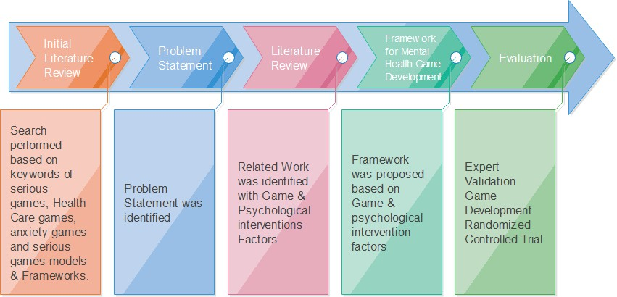

Figure 1 Research Methodology
  - Summary of this Chapter
This chapter provides an overview of the research methodology that will be used in our research.

Chapter 4: Proposed Work
After conducting the literature review, efficient Psychological interventions were identified and factors were extracted, which are later mapped into the game elements and a model is proposed to guide the development of games.
  - Psychological Interventions
Psychological interventions are actions performed to bring about change in people’s Behaviour emotions and feelings. It includes many treatment methods Cognitive Behavioural Therapy (CBT), Dialectical Behavioral Therapy (DBT), Behavior therapy, Interpersonal therapy (IPT) & Prolonged Exposure Treatment (PE).
The interventions used to develop the game framework are Cognitive Behaviour theory and Behaviour change techniques. BCTs prove to be effective when using in health apps, a systematic review was conducted that showed that that the most common and effective BCTS were “Feedback & monitoring” and “Goals and Planning” which were effective in enhancing physical activity behavior in users using digital applications [31]. Another research showed that self-monitoring and self-regulatory techniques in BCT derived from control theory were significantly more effective than interventions not including these techniques to promote physical activity and healthy eating[32]. One more study was conducted that showed significant trend towards greater improvements in health outcomes with employment of more BCTs per study.
Rahmani and Boren did a literature review of Randomized Controlled Trials [33] which were held in order to evaluate the effectiveness of videos games on health outcomes. It was concluded that most of the articles had a positive and promising effect of using games to improve health and had the potential to be used in pain management, diagnosis and a tool to improve health outcomes. Games that include concrete psychological interventions are still limited, most of them just have text regarding self-help implemented in games.
    - Behaviour Change Technique:
Behavior change techniques which are “observable, replicable, and irreducible component[s] of an intervention designed to alter or redirect causal processes that regulate behavior”. The whole

treatment with this therapy is divided in 16 categories [34], these categories are the steps to be taken to help bring a positive change in a person, these include
- Goals and planning
This includes Goal setting, Problem solving, Action planning, Review behavior goal outcome & review.
- Feedback and monitoring
This category deals with the feedback related to Behaviour, its outcomes and self- monitoring outcomes of desired Behaviour
- Social support
Social support which include both practical and emotional.
- Shaping knowledge
With demonstration or instructions on how to perform and achieve a Behaviour.
- Natural consequences
Includes techniques that explain the consequences of the performed action on health, environment emotions and on oneself.
- Comparison of behavior
These techniques motivate an individual by doing the results comparison with other people.
- Associations
This category includes giving prompts and cues, cue signaling reward, exposure and associative learning.
- Repetition and substitution
Behaviour substitution, habit formation & graded tasks
- Comparison of outcomes
Includes techniques such as comparative imagining of future outcomes.
- Reward and threat
Material incentives and rewards, social rewards and incentives and self-rewards.
- Regulation
Include stress management techniques that reduces anxiety.
- Antecedents

Antecedent stimuli activate centers of the brain involved in motivation, it consists of Adding objects to the environment in order to facilitate performance of the behavior
- Identity
It involves identification of self as role model and value self-identity techniques.
- Scheduled consequences
Behaviour costs, rewards and punishments.
- Self-belief
Motivate a person by verbal persuasion about capability and self-talk.
- Covert learning
Includes fictional punishment and reward.

    - Cognitive Behaviour Therapy
Cognitive behavioral therapy (CBT) is a collaborative, structured, skill-building, time-limited, and goal-oriented intervention designed to target core components of a given disorder [28].
CBT has proven to be an effective treatment for many psychiatric conditions. In a meta-analytic review of controlled trials, Lynch et al. (2010) found CBT to be an effective intervention in the treatment of major depression.
The result of numerous research work shows that using CBT in patient’s treatment improves the functioning and quality of life. Proudfoot [35] discussed in his research the effectiveness of computerized CBT treatment for mental health issues in general practice by introducing a program called beating the Blues. It was an interactive, multimedia, computerized–cognitive behavioral therapy package consisting of 2 parts: Cognitive and Behavioral. I also conducted an interview with the psychologists to know the common practices in psychology. Interview questions are attached in the appendix. Findings from the study indicated that stress patients who experience stress are more males than female, according to the psychologist there is a 70:30 ratio between male and female patients of stress. According to psychologists commonly used technique is CBT, and Behaviour change techniques can be used in treatments to help patient modify his habits and adapt a more efficient routine that helps him in lowering stress levels. CBT is one of the many psychological therapies being used today, that has some important principles on which the whole

treatment lies, and every individual is different when it comes to his treatment, but these underlying CBT principles remain the same for the treatments foundation.
      - Cognitive Behaviour Therapy Principles
Following are the principles adapted from Cognitive Therapy: Basics and Beyond by Judy Beck (1995).
        - Cognitive behavior therapy is based on an ever-evolving formulation of patients’ problems and an individual conceptualization of each patient in cognitive terms.
        - Cognitive behavior therapy requires a sound therapeutic alliance.
        - Cognitive behavior therapy emphasizes collaboration and active participation.
        - Cognitive behavior therapy is goal oriented and problem focused.
        - Cognitive behavior therapy initially emphasizes the present.
        - Cognitive behavior therapy is educative, aims to teach the patient to be her own therapist, and emphasizes relapse prevention
        - Cognitive behavior therapy aims to be time limited
        - Cognitive behavior therapy sessions are structured.
        - Cognitive behavior therapy teaches patients to identify, evaluate, and respond to their dysfunctional thoughts and beliefs

Principle 1: This focuses on identifying different factors of patient, which includes the current thinking of patient, its problematic behaviors (the actions one takes) and the triggering Factors that influence one’s perceptions.
Principle 2: It requires a good client-therapist relationship. To show an individual regard by making empathic statements. Giving one feedback on one’s small and larger actions and successes by being optimistic.
Principle 3: It states to view therapy as a teamwork; encourage individual to be active in therapy sessions, identifying the distortions in one’s thinking, summarizing important points, and devising homework assignments.
Principle 4: It deals with analyzing all the problems and setting specific goals. These goals can be in terms of behavior for example to initiate new friendships.

Principle 5: CBT initially emphasizes the present.

Principle 6: Educating individual to one’s problems with solution, aims to teach the client to be his/her own therapist, and planning behavioral changes.
Principle 7: CBT aims to be time limited.

Principle 8: CBT sessions are structured, this includes an introductory part (doing a mood check, briefly reviewing the week, collaboratively setting an agenda for the session), a middle part (reviewing homework, discussing problems on the agenda, setting new homework, summarizing), and a final part (eliciting feedback).
Principle 9: It includes the process of guided discovery, & using questioning (often labeled or mislabeled as “Socratic Questioning”) to evaluate their thinking. CBT uses a variety of techniques to change thinking, mood, and behavior.
      - Cognitive Behaviour Therapy Elements
CBT have several different types and applications [36] which emphasis on cognitive reformation, modifying behavior, and developing alternative coping skills. Some widely used common principles and elements which are:
- Collaborative empiricism : which involves a systemic process of therapist and patient working together to establish common goals in treatment [37]
- Problem-oriented focus: the reason why a problem emerged, goals of feeling good.
- Short-term treatment for uncomplicated disorders
- Structured methods: Establish a whole treatment plan which should include complete sessions with a recognizable start, middle and end.
- Psychoeducation: uses illustrations from the patient’s own experiences to demonstrate CBT principles and procedures.
- Homework

  - Mapping of Psychological Interventions Factors to Game design Elements Elements based on principles of Cognitive Behaviour theory and Behaviour change techniques are mapped with game elements.

    - BCT principle mapping with serious game elements
Table 2 shows the mapping of Cognitive Behaviour theory with game elements.

Table 2 BCT principle mapping with serious game elements

BCT | Category | Game Element | Reference
Goals and planning | Game Goals | Challenges  Rules | (Adams,2009)
Feedback and monitoring | Feedback | Level indicator  Points Leaderboard | (Adams, 2009)
Social support | Interaction | Collaboration  Roles | (Sheldon, 2011)
Shaping knowledge | Competences | Skills  Logical Challenge Knowledge | (Adams, 2009)
Natural consequences | Feedback | Level indicator Points  Leaderboard | Adams, 2009  Adams, 2009  (Sheldon, 2011)
Comparison of behavior | Feedback Interaction | Leader Board | (Sheldon, 2011)
Associations | Reward | Badge | (Adams, 2009)
Repetition and substitution | Game Goals | Challenges, Graded  Tasks | (Adams,2009)
Comparison of outcomes | Feedback | Leaderboard | Adams, 2009
Reward and threat | Reward | Score, Bonus  Badge | (Adams, 2009)

Regulation | Competence | Learn Skill to learn  Stress Management | (Adams, 2009)
Antecedents | Immersion | Game Flow  Loosing Self in Challenges Environment  Challenges | (Zhang, 2008)
Identity | Immersion | Avatar,  Identity associated  with changed behavior | (Zhang, 2008)
Scheduled consequences | Reward and Punishment | Tasks, Challenges, Health & Dying Start of Level Lives  Lost Progress | (Adams, 2009) (Fitz-Walter, Tjondronegoro, & Wyeth, 2011)
Self-belief | Feedback | Motivational  Messages from game | (Adams, 2009)
Covert learning | Reward and Punishment | Health & Dying Start of Level Lives  Lost Progress | (Adams, 2009)

    - CBT principle mapping with serious game elements
Mapping of Cognitive Behaviour theory principles are mapped with game design factors, which is shown in table 3.
Table 3 CBT principle mapping with serious game elements

Principle | Category | Game Elements | Reference

Cognitive behavior therapy is based on an ever-evolving formulation of patients’ problems and an individual conceptualization of each patient in  cognitive terms | Game Goals | Challenges | (Adams,2009)
Cognitive behavior therapy requires  a sound therapeutic alliance. | Interaction | Collaboration  Roles | (Schultheiss,  2001).
Cognitive behavior therapy emphasizes collaboration and active  participation. | Interaction | Collaboration Roles | (Schultheiss, 2001).
Cognitive behavior therapy initially  emphasizes the present | Game Goals | Clear Game Goals | (Adams,2009)
Cognitive behavior therapy is goal  oriented and problem focused. | Game Goals | Goal | (Adams,2009)
Cognitive behavior therapy is educative, aims to teach the patient to be her own therapist, and emphasizes  relapse prevention | Autonomy | Freedom Narrative | (Wang, Khoo, Liu, &  Divaharan,  2008)
Cognitive behavior therapy aims to  be time limited | Game  Mechanics | Time
Cognitive behavior therapy sessions are structured. | Interactive | Timeline Levels | (Sheldon, 2011)
Cognitive behavior therapy teaches patients to identify, evaluate, and respond to their dysfunctional  thoughts and beliefs. | Competence | Skills Knowledge | (Adams, 2009)

    - CBT Elements mapping with serious game elements
Mapping of Cognitive Behaviour theory elements extracted from principles are mapped with game design factors, which is shown in table 4.
Table 4 CBT Elements mapping with serious game elements

CBT Element | Category | Game Element | Reference
Collaborative empiricism | Interaction | Collaboration Feedback  Reward | (Sheldon, 2011)
Problem-oriented focus | Game Goals | Goal  Challenges | (Adams,2009)
Time Limited | Feedback | Levels  Timeline | (Adams, 2009)
Structured methods | Feedback | Timeline  Levels | (Adams, 2009)
Psychoeducation. | Competence | Skills, Knowledge, Expert Guidance, Modelling of  Behaviour. | (Adams, 2009)
Homework: | Game Goals | Tasks, Challenges | (Adams,2009)

  - Framework
After conducting the literature review, efficient Psychological interventions & Game elements were identified and factors were extracted, which are we later mapped into the game elements and a framework is proposed to guide the development of games. Cognitive Behaviour theory and Behaviour change techniques were chosen to be applied on game elements. Game design factors we considered for framework are Game Goals, Interaction (Interactivity), Autonomy, Immersion, Competence, Feedback, Rewards & Punishment.

According to Oxford Dictionary Game goals are the objectives to be achieved by the player, in order to succeed. These goals aim to work towards self-improvement, motivation to adapt positive lifestyle changes and to complete work objectives. Goals and rules makeup a game, guiding player on how to play a game, giving him sense of accomplishment & progression[38].
For progression towards a goal, a player needs Feedback. Feedback types can vary, it can be present in comparison which compares the results of players, evaluate results or simply show the progress and performance. These different types have different positive effects on health outcomes [39]. According to Burgers et al. research positive feedback, fulfills the needs of competence and autonomy which in turn increases intrinsic motivation. Feedback enhances motivation, it can be more enhanced by Rewards in a game, and there are two types of rewards extrinsic rewards (i.e. Badge, Points) and intrinsic reward (i.e. learning a new skills or for the sake of reputation). In serious games when developed for mental health domain, one important factor is to show natural consequences to player, to implement this feature, punishments can be used in games, and these include Lost Lives of player, progress lost or taking away the rewards of the player.
Serious Games provide a safe environment to a player that allows him to see his potentials of how much he can take the pressure and how will he behave in real life when the situation comes, Autonomy factor in a game allows a player to feel in control, because of safe environment he can risk taking decisions that changes the whole narrative in the game. Autonomy enables freedom, decisiveness and presence of choice [36]. To increase motivation, autonomy plays a vital role. For higher perceived autonomy a player must complete game challenges for his own interest and personal[40].
To create a flow in game, to maintain engaging a player in a game so that he continues playing and the desired treatment, it’s important to consider immersion factor. According to Baek et al. immersion can create personal and emotional experience for the player, causing him to lose himself in the challenges. Loosing self in challenges does not mean losing his conscious, this creates a stronger sense of self among player. This experience proves to be very therapeutic, by decreasing stress levels of the player [41].
In serious games a balance needs to be maintained between elements of fun and learning, when implemented in the domain of mental health and psychology, we need to keep in mind the

psychological theories on which our framework is based. One important elements in psychological intervention is Collaborative Empiricism, for this interaction factor is added in the framework. Interaction enables collaboration between players and different roles can be assigned in a game for interaction. Literature found on interaction depicts that it has two kinds: interactions between the Game and Player and collaboration between players. Learning is an essential part in serious gaming, so competence plays a major role in development. It involves skills, knowledge and abilities. Competence are implemented with challenges, which can be physical and logical both.
After considering these game factors identified from literature, we have mapped them into psychological interventions which leads to the treatment being done with the help of serious game.
After this literature review, we have identified & mapped game design factors with psychotherapies and framework is proposed and shown in Figure 2.
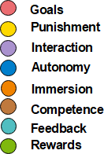

Figure 2 shows the color coding of framework elements

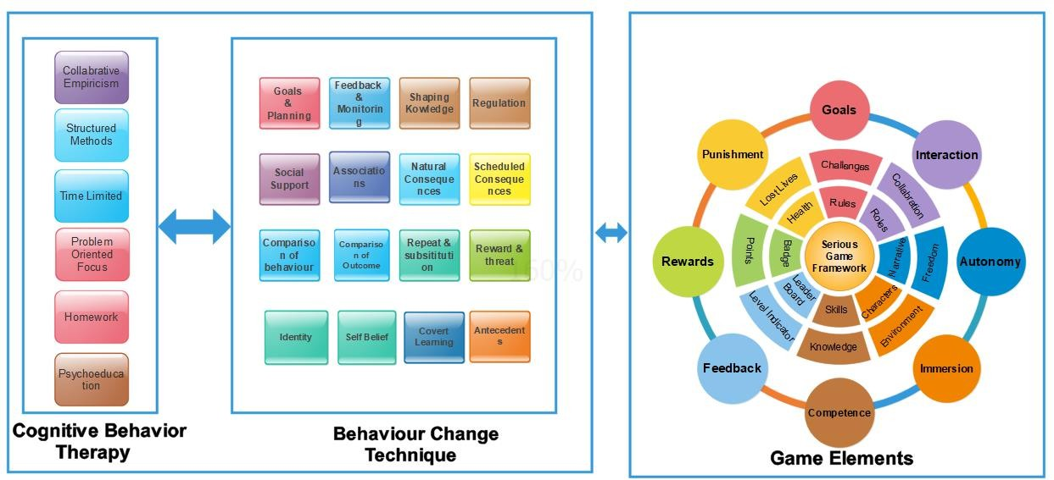
Figure 3 Proposed Framework for developing Serious Game for Mental Health

  - Summary of this Chapter
In this chapter we have presented a mapping of Game elements with Behaviour change techniques and Cognitive Behaviour theory. We have established game elements categories of Game Goals, Interaction, autonomy, Competences, Feedback, rewards and punishments and immersion to be included when designing serious games for mental health.

Chapter 5: Evaluation
Expert Evaluation was done on proposed Framework and randomized controlled trial was conducted on students experiencing stress where they were divided into two groups, one had to play game with proposed design factors and other group played game without these game design factors. A device “ProComp Infinit System” was used to measure stress levels of the player by considering parameter Heart rate variability.
  - Framework Validation

Framework was validated by experts.

    - Data Collection, Recruitment and Analysis

In order to know that the proposed framework when applied to games give significant result in lowering stress levels expert validation was performed with 30 experts. This evaluation involved 5 Serious Game researchers, 17 Game developers, 3 Psychologists, 4 Pro Game Players and one Gamification Consultant.
    - Recruitment of Expert Participants

A purposive sampling method was used to recruit the experts[42] [43] (the researcher trusts his own judgement to recruit the experts from a population).Experts were recruited based on their research interests & work experience related to Mental Health and developing games. Experts were contacted through emails to fill out the designed questionnaire. A document was sent with the invitation email which consisted of background of the study and the research objectives. Data collection was done until no new suggestions and results emerged [44].

    - Experts Demographics
Table 5 Experts Demographics

Expert | Designation | Year of Experience | Research Interests
P1 | Serious Game Researcher | 20+ | designing, researching and producing serious games
P2 | Serious Game Researcher | 6 | Game Researcher and gamification study
P3 | Serious Game Researcher | 5 | Serious Games
P4 | Serious Game Researcher | 5+ | Researcher, Gamer, community manager, world builder and developer
P5 | Serious Game  Researcher | 2 | Serious Games for Learning
P6 | Psychologist | 30 | Stress Reduction
P7 | Psychologist | 22 | Anxiety
P8 | Psychologist | 5 | Human Well Being
P9 | Game Developer | 8
P10 | Game Developer | 7

P11 | Game Developer | 6
P12 | Game Developer | 6
P13 | Game Developer | 5
P14 | Game Developer | 5
P15 | Game Developer | 5
P16 | Game Developer | 4
P17 | Game Developer | 3+
P18 | Game Developer | 3
P19 | Game Developer | 3
P20 | Game Developer | 3 | Marketing
P21 | Game Developer | 2+
P22 | Game Developer | 2
P23 | Game Developer | 2
P24 | Game Developer | 1
P25 | Game Developer | 1
P26 | Game Player | 5
P27 | Game Player | 10
P28 | Game Player | 5+
P29 | Game Player | 5
P30 | Game Designer | 5+ | Gamification Consultant

The purpose of the evaluation survey is to give an indication of whether the game elements included in the framework would affect the stress levels of players.

    - Questionnaire

A Likert Scale (Strongly Agree, Agree, Undecided, Disagree, Strongly Disagree) questionnaire was designed was considered the most appropriate method for collecting data from experts. Both open ended and close ended questions were used in the questionnaire which allowed the experts to give their feedback and expert views on the elements of framework.

    - Analysis

Results from this initial evaluation provide initial evidence that implementing psychological interventions along with game factors in a game will bring positive outcome on a person’s health. Around 85.2% experts agreed that Game design factors can add more value to the game and more than 70% agreed that Psychological Therapies of Cognitive behavior theory (CBT) and Behavior change technique (BCT) can be used when designing games for mental health. When dealing with stress and anxiety, reducing person’s negative thinking is important, for this purpose positive

affirmations are used and player needs to be educated about how to handle the situation, 48% experts agree & 33% experts strongly agree that person can be educated about handling stress through game elements of Goals, Challenges and Knowledge. When designing serious games it is important to consider that player needs to be motivated, engaged and educated at the same time, otherwise the purpose of serious gaming is lost. Following figures show the individual results of the survey questions:

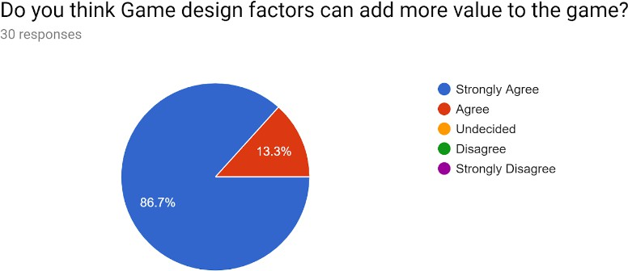
Figure 4 Survey Question 1 Results
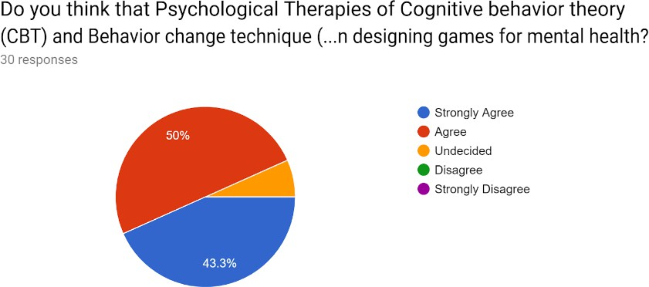

Figure 5 Survey Question 2 Results

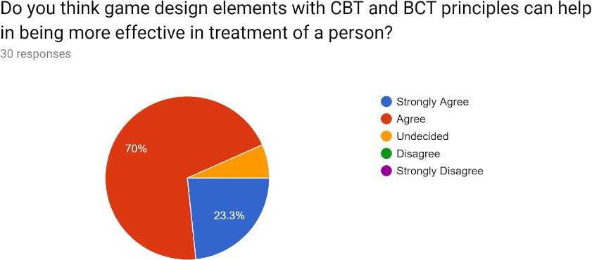

Figure 6 Survey Question 3 Results

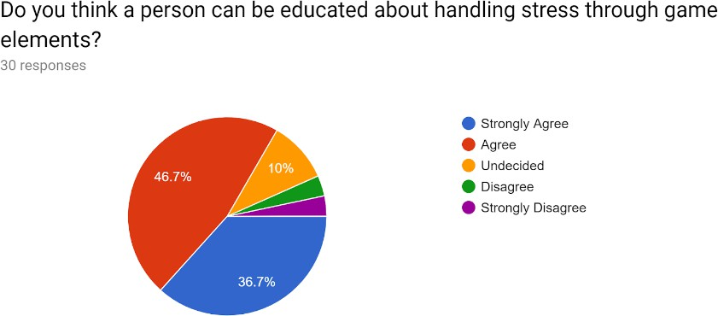

Figure 7 Survey Question 4 Results

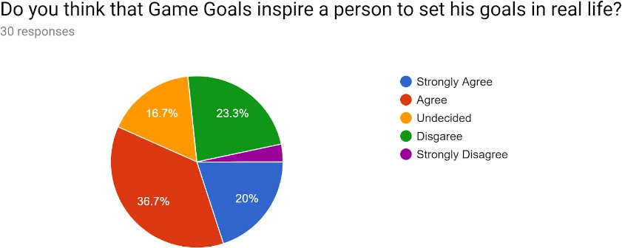

Figure 8 Survey Question 5 Results

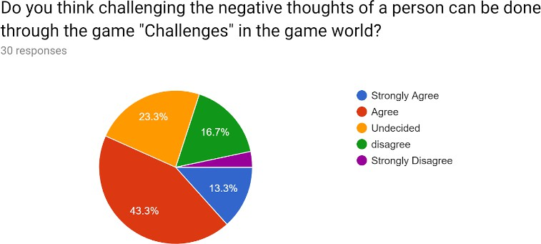

Figure 9 Survey Question 6 Results

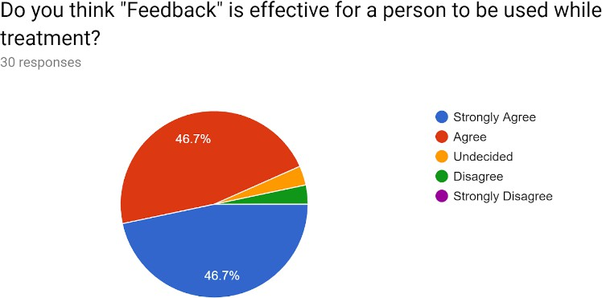

Figure 10 Survey Question 7 Results

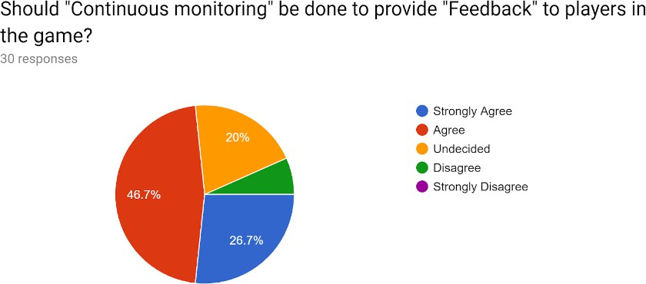

Figure 11 Survey Question 8 Results

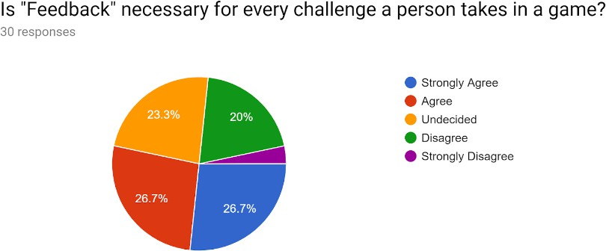

Figure 12 Survey Question 9 Results

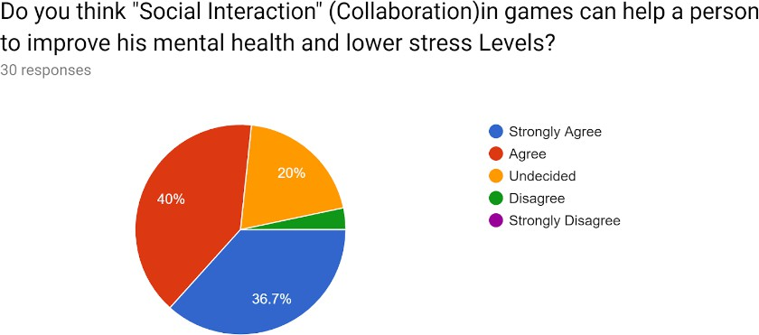

Figure 13 Survey Question 10 Results

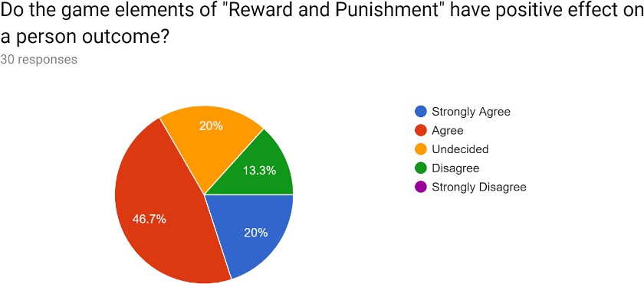

Figure 14 Survey Question 11 Results

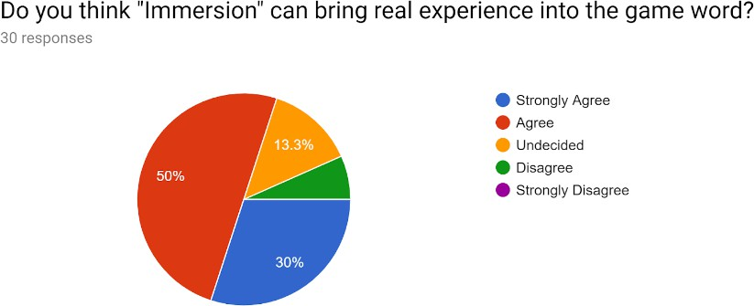

Figure 15 Survey Question 12 Results

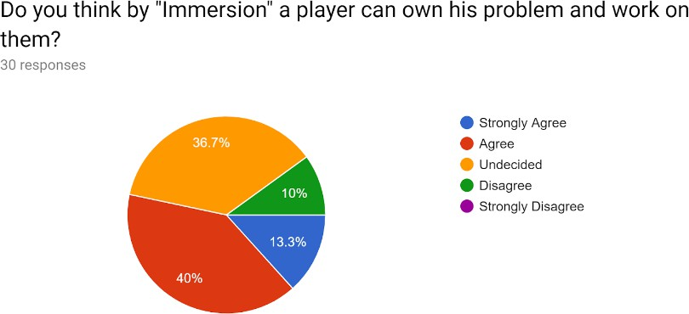

Figure 16 Survey Question 13 Results

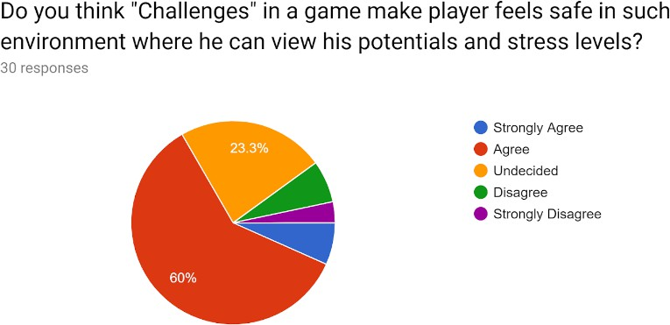

Figure 17 Survey Question 14 Results

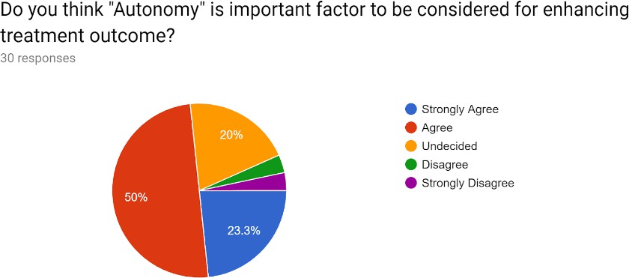

Figure 18 Survey Question 15 Results



Expert Validation
Strongly Agree Agree Undecided Disagree Strongly Disagree

25
20
15
10
5
0

Figure 19 Results of Expert Evaluation

As mentioned above, there are many factors where experts agree that they can be useful in lowering stress levels of players, 55% agreed that goals in game inspire players to set goals in real life. With the help of planned challenges, psychological interventions be held. More than 40% experts agree with this.

When dealing with behaviors of the players , the one thing that helps in greater productivity is the feedback to players on their performance, and rewards for the desired behavior that they depict

[45]. When asked about the importance of Feedback element in the proposed framework only 3.7% experts believed that "Feedback" is not effective for a person to be used while treatment, rest of the experts reviewed it to be important but 83% experts believed that feedback is necessary for every challenge in a game, because the findings suggest that no feedback might do more harm than negative or positive feedback. Feedback results in rewards or punishment for a player, because it informs the learner if one did the right thing or the wrong thing. Over half of the respondents agreed that game elements of "Reward and Punishment" have positive effect on a person outcome.

In daily life many events can result in the increase of stress in a person, so to be able to track what causes stress increase and at what time the stress increases it is important to continuously monitor an individual in games. By Continuous monitoring of an individual’s stress levels it proves to be essential to manage stress and mental state in an effective way[46]. This factor can also provide the user with the details of his/her stress levels[47].The significance of "Continuous monitoring" in game challenges was agreed upon by 74% of the sample.
Collaboration in mental health means sharing of experience, perspective, knowledge, and skills, in games they players can also be encouraged to work together and collaborate as they progress towards common goals. More than 48 % agreed that “Social Interaction" (Collaboration) in games can help a person to improve his mental health and lower stress Levels. Unfortunately serious games nowadays allow just single player experience and lack multi-player features in them.

Immersion in games plays an important roles in games, it creates an environment that the player loses himself in the game and gets more involved in the challenges, this can be achieved by giving player clarity of goals and quick feedback, concentrating and focusing tasks, lack of self- consciousness, balance between the challenge and the skills required to complete it, and in the end giving him full control over his activities in the game [48]. More than 50 % agree immersion plays important role in games designed for mental health. Psychologists believe that therapies for stress patients should be educating which teaches them to be their own therapist, and emphasizes on relapse prevention by motivating a patient to take decisions.

One important part in mental health treatments is Relapse Prevention. Relapse occurs due to triggers, which are caused by People, place and things that increases the chance of a person to

relapse. This is dealt by educating a person on how to avoid situations like these. In order to make him stronger on his will, games should have autonomy and challenges, as 62% experts agree with the concept that a player can take decisions and chose any path to the destination facing consequences and at the same time being safe in game world where he can view his potentials and stress levels [49]. About 70% experts agreed that autonomy makes a player own his problem and increase his motivation while achieving the desired Behaviour.

  - Game Implementation

For the evaluation purpose, two versions of the game were developed on Unity, one version was based on the proposed framework with game elements present in it and in the other version did not have any of those game factors.

    - SyncEscape With Game Elements

The aim of this implemented game is to reduce stress in a player. In this game a user has a player in the form of two character which are connected in a circle that means they are moving simultaneously and he can control this player by rotating left and right. He needs to save his player’s life by getting more bonus points which are present in the shape of balloons and getting safe by not touching the obstacles in the game. Every Bonus points contain a relaxation technique that he has to follow in order to get bonus points in the game. Every Level targets a psychological treatment goal. The objective of this game to reduce stress in a player, by teaching him to how to handle negative thoughts and be positive.

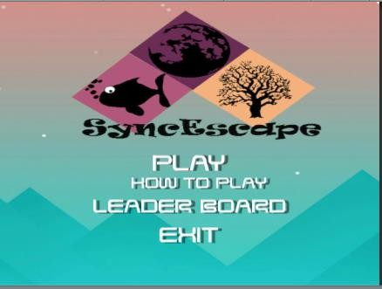
Figure 20 SyncEscape Landing Page
The main menu has the options of start playing, instructions, leaderboard and exit. How to play button takes the player to screen shown in figure 20, with guidelines on how to play the game.
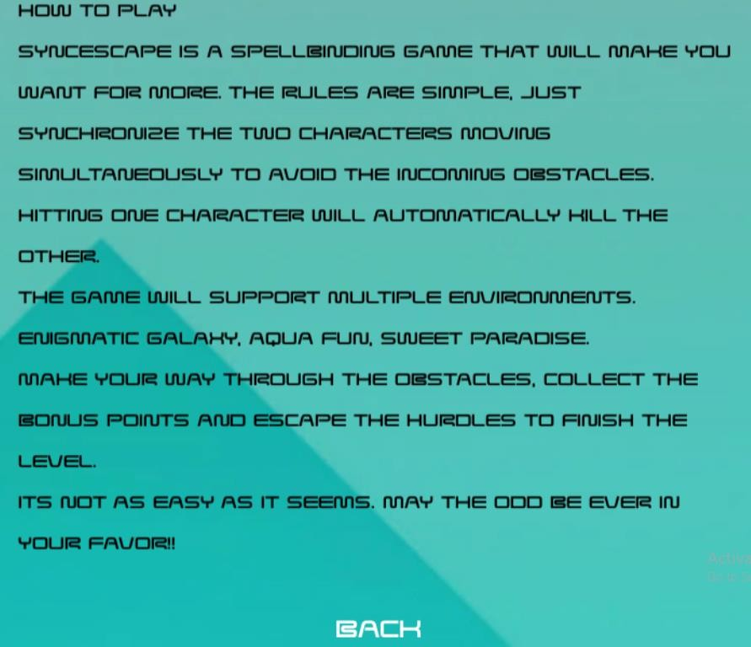
Figure 21 Game Guidelines and Game rules

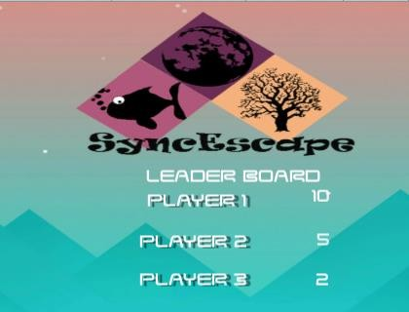
Figure 22 SyncEscape Leaderboard
It gives players the options to play games in three different environments, giving him a sense of ownership over his actions.

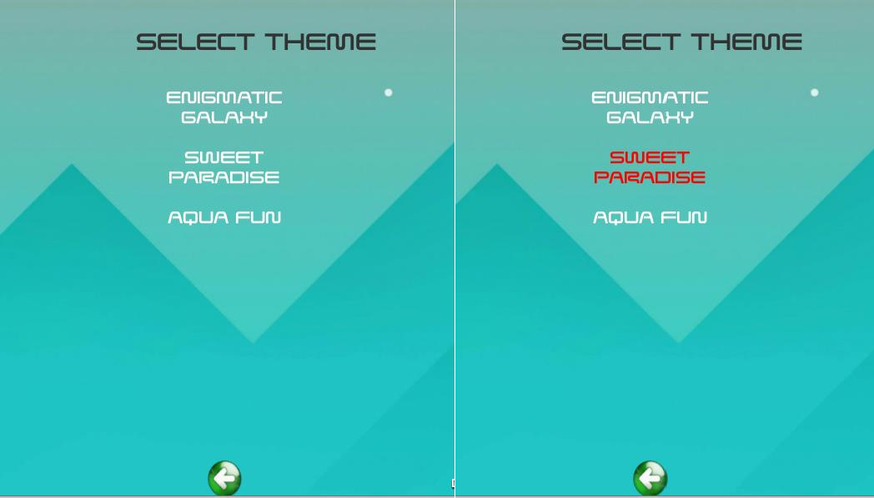
Figure 23 SyncEscape Environments Selection Menu

Once a player selects an environment he is displayed with two levels, every level has a goal and in order to achieve this goal, challenges are implemented according to it and a player has to follow rules to achieve those goals and complete challenges. Figure 23 shows the level menu.

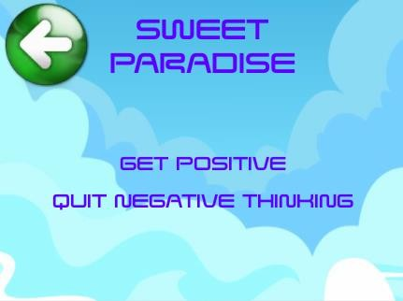
Figure 24 Game Levels Menu
Figure 24 shows the screen of the game once the game starts, it shows the level’s character, a progress bar, score, level indicator and bonus point (Balloon).
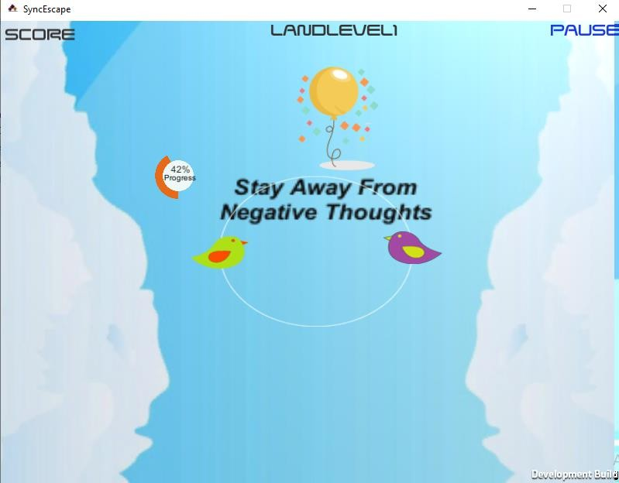
Figure 25 Screenshot of the game, once the player start playing Level 1.

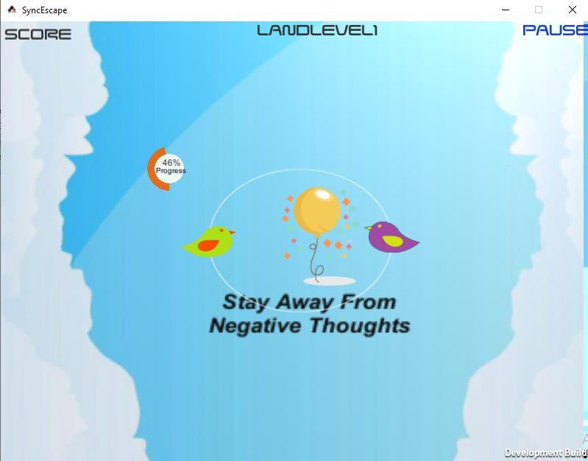
Figure 26 Screenshot of SyncEscape game.
Figure 26 shows the explosion particle system when a player takes a bonus point, this is used to enhance the immersion experience.
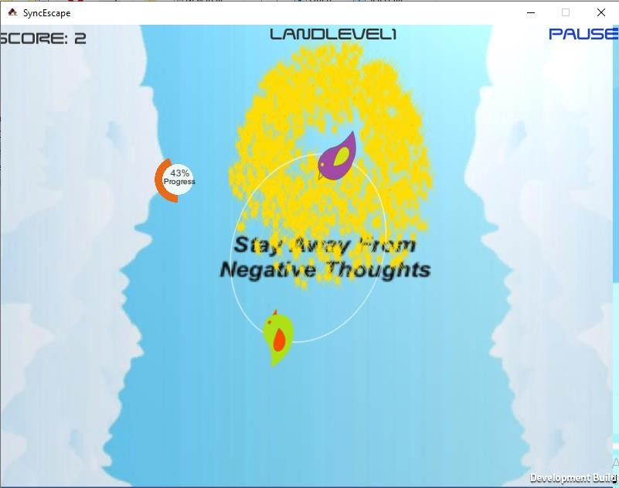
Figure 27 Screenshot of the Game, when a player collects a Coin
When a player finishes both levels, he is awarded with a reward in form of a new environment being unlocked to the player, a space environment. This is showed in Figure 27.

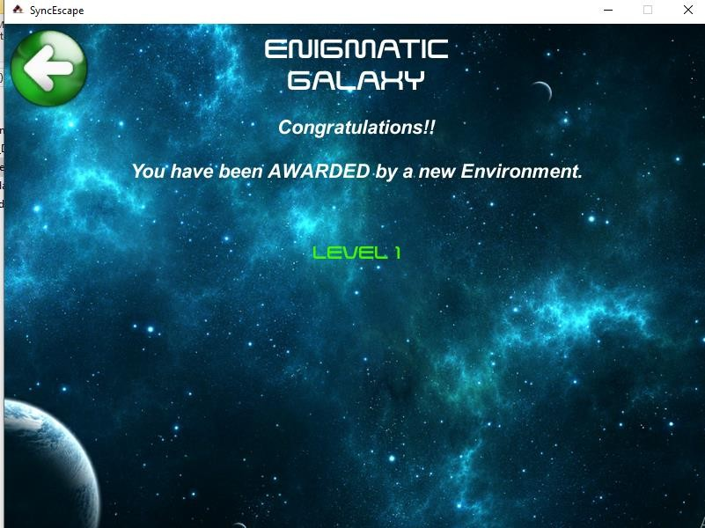
Figure 28 SyncEscape Reward Screen
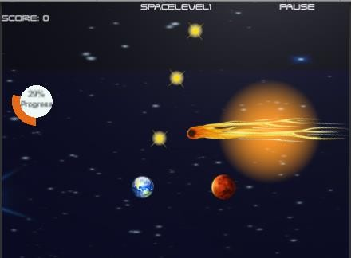
Figure 29 Screenshot of SyncEscape Space Level 1.

Table 6 Game elements present in SyncEscape game

Game Factors | Implementation in Sync Escape Game
Game Goals | First two games had the objective to increase Positive Thinking in a  player & to help him to fight and eliminate his Negative Thoughts.
Interaction | It had leaderboard which showed score of players who played this game.

Autonomy | Player had the freedom over their actions in a game, they were free to  play the game how they wanted it to be and shape its narrative according to themselves.
Immersion | Immersion was increased in the game by introducing multiple  environments in a game, each with its own story and character
Competence | SyncEscape teaches stress management knowledge, skills and how to use  them.
Feedback | SyncEscape gives feedback to players inform of scores, leaderboard, level  indicator, progress indicator and rewards to unlock new levels.
Rewards | The rewards are based on coin collection to score more points.
Punishment | If the player does not escape the negative thought enemy, he dies and  loses his levels progress.

    - SyncEscape Without Game Elements

The second version of the game dint have any game elements that were considered for game version 1.
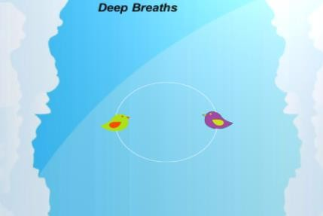

Figure 30 SyncEscape Version 2: Without Game Elements
It did not have game elements of Rewards and punishment, any immersive experience, collaboration and autonomy elements.

  - Difference between Game Version 1 and Version 2

Table 7 shows the difference in game design factors present in both the versions of the game

 | Game Goals | Interaction | Autono my | Immersio n | Comp etenc e | Feedback | Rewar d | Punish ment
SyncEscape Version 1 | Yes | Yes | Yes | Yes | Yes | Yes | Yes | Yes
SyncEscape Version 2 | Yes | No | No | No | Yes | Yes, with just one Feedback | No | No

  - Conducting Controlled Experiment

To conduct this experiment, physiological signals that are related to mental stress were measured and these are explained in detail in the following section.
    - Physiological Signals related to mental stress
Human body is designed to adapt, and respond to many situations. These situations can be difficult, or dangerous, and body will respond in a way to best deal with these situations. The body’s autonomous nervous system (ANS) is kind of a preprogrammed computer, which starts changing body’s physiological states as soon as it detects stress. This is called ‘fight or flight response’ of the body.
A state where a person remains in a stressful condition for a prolonged time, or frequently, without getting time to relax leads to a condition most commonly known as distress. It is a negative stress reaction, and lead to body losing its equilibrium and balance, physical symptoms such as headaches, stomachaches, chest pains, sleep disorders and irritable skin conditions. Psychologically, distress can cause temporary and mild dementia, panic attacks and anxiety and paranoia. Research has shown that stress can worsen these conditions. Following are physiological parameters that will be measured in this experiment to see change in physiological signals, which leads to the result that whether stress increases or decreases.

Skin Temperature
Skin temperature is a parameter that body controls very efficiently. A lot of body functions rely on skin temperature, and in general control of body temperatures. With any external trigger, body can change the temperature of the skin, indicating that more blood is being channeled to that particular region of the skin. This physiological parameter, skin temperature, can also be used to measure and quantify the level of stress that a person is experiencing.
The average physique temperature of an individual is around 36°C - 37°C. When we relax, our blood vessels dilate, causing the blood to get a little warmer, but it will not change the core temperature of the body [50]. When the body temperature rises it reduces the heat production whereas when the body temperature falls then it leads to increase in heat production. The general body temperature ranges from 15.5 °C - 37.2°C. As indicated by literature, the body temperatures that are correlated with stress are represented as follows
Table 8 Body Temperature correlated with stress

Temperature | Condition
Below 26°C Highly Tensed | Below 26°C Highly Tensed
26-29°C Slightly Tensed | 26-29°C Slightly Tensed
29-32°C Mildly Calm | 29-32°C Mildly Calm
32-35°C Quietly Relaxed | 32-35°C Quietly Relaxed
Above 35°C Deeply Relaxed | Above 35°C Deeply Relaxed

Hearty Rate Variability
The stress can be identified using Heart rate variability (HRV). HRV is regulated based on the Autonomous Nervous System (ANS). HRV is assortment in time break of heart beats. HRV is based on beat-to-beat interval. HRV varies for every individual person based on their Health condition. When HRV value is above 50 then that concern person is said to be fit and healthy [51]. If HRV value is 14 to 25 then the person is slightly tensed and if the HRV value is between 2 to 15, then the person is hyper tensed.

Galvanic Skin Response
GSR works with the activity of electrical conductance of skin, sweat and variation of moisture level of person. The electrical skin conductance increases when the person starts to sweat and these can be measured by GSR sensors [50]. The skin conductance of the person can be changed by the emotions such as happiness, sadness, frustration, stress, shock, depression and other similar emotions.

Methodology
Following methodology was followed for the experiment.

Subjects
40 healthy participants, from Riphah International University, Pakistan (29 Male, 11 female) with mean age 21 ± 2 years, voluntarily participated in this study. All subjects signed consent forms before participating in the experiment. No subject had history of any psychological or cardiovascular disease. This study was approved by Ethical Approval Committee, Riphah International University, Pakistan.

Data Acquisition
All data was acquired using ProComp Infinit System by Thought Technologies Ltd. The system is a specialized instrument designed to measure and quantify stress using a number of physiological signals. Specifications of the system are given in table 9.

Experimental Protocol
All subjects were randomly assigned to a group (Game with, Game without). A power analysis was conducted in order to evaluate the number of subjects required to detect a significant difference between the groups. The analysis showed that a sample of 18 is required for each group, with α = 0.5, two-tailed test. Both male and female subjects were included in the test.
Each subject was asked to sit in a comfortable position, and electrodes were attached on subjects’ hand as shown in the figure 30.

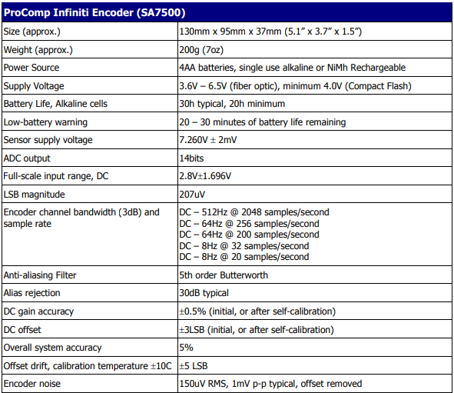

Table 9 Hardware specifications of the physiological measurement system used for the study

The electrodes were attached to measure EDA, Blood volume changes, and skin temperature. After electrodes were placed, a 2-minute data was collected to get a baseline reading of the subject. Subjects were asked to stay in calm relaxing state during this time. After 2 minutes of base line data, each subject was given a game to play according to which group he was assigned at the beginning of the recruitment. Another 2-minute data was collected from the subject while he/she was playing the game.
Results were computed for the 2 minutes of game playing time by using baseline data as reference for each subject.

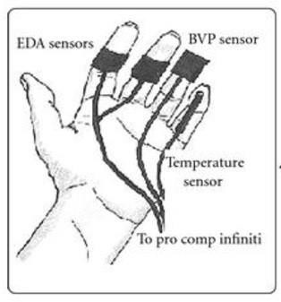
Figure 31 Placement of electrodes for measurement of physiological signals during the study

    - Results
The stress levels results of the participants that played Game with (Version 1) and Game Without (Version 2) have been presented in this section.
      - Heart Rate Variability
- Time Domain Features
A Total of 11 Time-Domain features were calculated for this study. The key value to calculate is the time between each heart pulse. This was calculated by finding peaks in each wave. Threshold value for each peak was different for each subject, as the amplitude of signal is different for each subject. Using this time stamp value of each pulse, 11 subsequent features were calculated for each wave, shown in Time domain features section in Table 10.
To find time domain features of each signal, first an array containing all time duration between each consecutive peak (Δt-PP) was calculated. Mean value of all the Δt-PP values is our 𝑃̅̅𝑃̅̅ value. Standard deviation of PP is calculated (SDPP) as follows

𝑆𝐷𝑃𝑃 = √ 1 ∑(𝑃𝑃
− 𝑃̅̅𝑃̅̅) (1)

𝑁−1 𝐽
2

Where PPJ denotes the value of j^{th} PP interval and N is the total number of successive intervals. Mean Peaks per minute (PPM) is calculated by taking average of all instantaneous peaks per minute values. Standard deviation of instantaneous peaks per minutes is calculated (STDPPM). Minimum and maximum PPM is calculated for 5 beat moving average.
- Frequency Based features
A total of 5 frequency domain features were calculated. Fast Fourier Transform (FFT) based Welch’s power spectral density estimate (PSD) was used to find low frequency (0.04 – 0.15 Hz) and high frequency components (0.15 – 0.4 Hz) of PP values. In order to decrease the variance of FFT spectrum, PRV samples are divided into overlapping segments. PSD is then obtained by averaging the spectra of these PRV segments. All the different features such as peak frequencies, absolute and relative power and power in normalized unit were calculated from PSD estimates.

- Non Linear Features
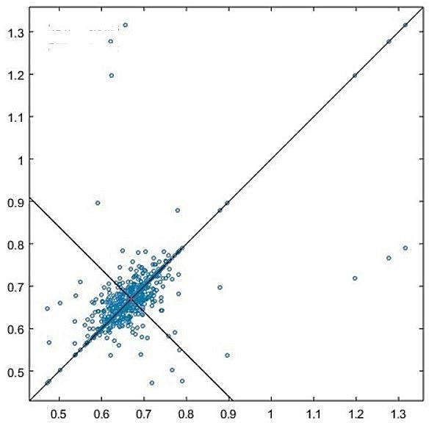
Nonlinear features were calculated. To calculate first non-Linear feature, PPn+1 were plotted as a function of PP values, also known as Poincare plot Figure. 31
Shifted time between consecutive peaks ( P(nn+1)

Time between Consecutive Peaks (PP(n) )
Figure 32 Poincare graph of one subject

To calculate the standard deviation of dispersion values, principal component analysis (PCA) was performed on the PPn+1 x PP Matrix. Shape of plot is very important to fit the ellipse which is oriented according to the line of identity (PP(n)=PP(n+1)). The standard deviation of points

perpendicular to line of identity is denoted by SD1 describing short term variability. SD1 can be calculated from standard deviation of successive PP (SDSPP) interval difference.
𝑆𝐷1² = 1 (𝑆𝐷𝑆𝑃𝑃)² (2)
2

The standard deviation of points along the line of identity is denoted by SD2 describing long term variability. SD2 can be calculated from SDPP and SD1
𝑆𝐷² = 2𝑆𝐷𝑃𝑃² − 𝑆𝐷1² (3)
Approximate entropy (ApEn) measures regularity and complexity of signals. Large ApEn value indicated low regularity and predictability and vice versa.
Sample entropy is similar to ApEn but the difference is that it provides more reliable and less biased measure of signal regularity and complexity. Correlation between successive PP interval over different time scale provides detrend fluctuation (DFA). DFA determine the statistical self- affinity of a signal by plotting a straight line on the log graph.

𝑋_{𝑡} = ∑^{𝑡}
(𝑥_{𝑖} − (𝑥))
(4)

𝑖=1
Where x denotes the mean value. Xt is divided into segment of equal length n. A least square line was fitted into each segment of the data by minimizing the squared error. An array Yt containing all piecewise straight-line fits was calculated. The F(n) was applied over different segment of length n. A graph is plotted between log n and log F(n). α is slop straight line fit to the log graph.

𝐹(𝑛) = √ 1 ∑^{𝑁} (𝑋 − 𝑌 )²
(5)

𝑁 𝑡=1 𝑡 𝑡
In DFA, correlations are divided in short term fluctuation (DFA α1) and long-term fluctuations (DFA α2).
Finally, Approximate Entropy and Sample Entropy was calculated for the PP vector. DFA1 and DFA2 were calculated.
Table 10 List of abbreviations for the features calculated from the heart rate variability data

S.N. | Abbreviation | Units | Description
Time Domain Features
1 | 𝑃̅̅𝑃̅̅ | [ms] | The mean of PP intervals
2 | SDPP | [ms] | Standard deviation of PP intervals
3 | PPM | [Beats/min] | The mean pulse rate

4 | STD PPM | [Beats/min] | Standard deviation of instantaneous pulse  rate values
5 | Min PPM | [Beats/min] | Minimum Pulse Rate computed using 5 beat  moving average
6 | Max PPM | [Beats/min] | Maximum Pulse Rate computed using 5  beat moving average
7 | RMSSD | [ms] | Square root of the mean squared differences  between successive PP intervals
8 | NNxx | [beats] | Number of successive PP interval pairs that  differ more than 50 ms
9 | pNNxx | [%] | NNxx divided by the total number of PP  intervals
10 | PRV triangular  index |  | The integral of the PP interval histogram  divided by the height of the histogram
11 | TINN | [ms] | Baseline width of the PP interval histogram
Frequency Domain Features (for low and high frequencies)
12 | Peak Frequency | [Hz] | Peak frequency of bands
13 | Abs. Power | [ms²] | Absolute power of Frequency Band
14 | Log Power | [%] | Natural Logarithmic value of Abs. Power
15 | Rel. power | [%] | Relative Power of frequency bands
16 | Normalized power | [Nu] | Relative power of frequency bands in  normal units
Non-Linear Features
17 | SD1 | [ms] | Poincare plot, standard deviation  perpendicular to line of identity.
18 | SD2 | [ms] | Poincare plot, standard deviation along line  of identity.
19 | SD ratio | [ms] | Ratio of SD1 to SD2
20 | ApEn |  | Approximate entropy (ApEn) which measure complexity and regularity of time  series
21 | SaEn |  | Sample entropy (SaEn) which measure  complexity and regularity of time series
22 | DFA α1 |  | Detrend fluctuation analysis which describe  short term analysis
23 | DFA α2 |  | Detrend fluctuation analysis which describe  long term analysis
24 | DFA ratio |  | Ratio of DFA α1 and DFAα2

The table below shows some of the Non Linear features calculated from the heart rate variability features calculated from both the groups “Game with Factors” and “Game without Factors”.

Table 11 Non-Linear feature Values calculated for the group (Game With) from the HRV Data

Game With Game design Factors
sd1 | sd2 | sdr | Apen | saen | dfa1 | dfa2 | dfr
18.735 | 49.961 | 2.6666 | 1.0122 | 0.83331 | 1.3918 | 0.45499 | 3.058968
6.1704 | 16.934 | 2.7445 | 1.0328 | 0.86925 | 1.3581 | 0.58607 | 2.3173
12.327 | 27.505 | 2.2312 | 1.0459 | 0.86166 | 1.1702 | 0.73278 | 1.596932
16.738 | 49.142 | 2.936 | 0.94372 | 0.74639 | 1.4598 | 0.51259 | 2.84789
15.349 | 53.069 | 3.4576 | 0.86047 | 0.68935 | 1.4845 | 0.53179 | 2.791515
10.093 | 41.451 | 4.1067 | 0.99457 | 0.83027 | 1.3861 | 0.7854 | 1.764833
15.021 | 45.306 | 3.0163 | 0.85603 | 0.66916 | 1.502 | 0.6175 | 2.432389
14.714 | 42.274 | 2.873 | 0.89622 | 0.72605 | 1.3789 | 0.68421 | 2.015317
13.176 | 34.792 | 2.6405 | 0.99383 | 0.84776 | 1.2092 | 0.70778 | 1.70844
18.741 | 41.789 | 2.2298 | 0.89054 | 0.69433 | 1.1547 | 0.47044 | 2.454511
14.493 | 39.197 | 2.7046 | 1.0131 | 0.82906 | 1.4325 | 0.60266 | 2.376962
18.579 | 55.85 | 3.006 | 0.96151 | 0.75245 | 1.2911 | 0.59307 | 2.176977
23.839 | 65.762 | 2.7585 | 0.88714 | 0.68738 | 1.2464 | 0.54021 | 2.307251
15.367 | 45.34 | 2.9505 | 0.90977 | 0.75457 | 1.4333 | 0.62394 | 2.297176
22.482 | 59.9532 | 3.19992 | 1.21464 | 0.999972 | 1.67016 | 0.545988 | 3.670762
7.40448 | 20.3208 | 3.2934 | 1.23936 | 1.0431 | 1.62972 | 0.703284 | 2.78076
14.7924 | 33.006 | 2.67744 | 1.25508 | 1.033992 | 1.40424 | 0.879336 | 1.916319
20.0856 | 58.9704 | 3.5232 | 1.132464 | 0.895668 | 1.75176 | 0.615108 | 3.417468

Table 12 Non-Linear feature Values calculated for the group (Game Without) from the HRV Data

Game Without
sd1 | sd2 | sdr | apen | saen | dfa1 | dfa2 | dfr
16.495 | 54.432 | 3.2998 | 0.9206 | 0.76722 | 1.3964 | 0.72625 | 1.922754
5.8505 | 15.571 | 2.6615 | 0.98754 | 0.8063 | 1.3521 | 0.68824 | 1.964576
8.3329 | 21.569 | 2.5884 | 1.0212 | 0.85825 | 1.2928 | 0.75411 | 1.714339
17.731 | 50.177 | 2.8298 | 1.0361 | 0.84278 | 1.3823 | 0.53458 | 2.585768
11.006 | 38.617 | 3.5089 | 0.91558 | 0.7616 | 1.6028 | 0.69682 | 2.300164
10.227 | 33.147 | 3.2413 | 0.96695 | 0.8515 | 1.2159 | 0.93712 | 1.297486
11.16 | 31.894 | 2.858 | 1.0157 | 0.83045 | 1.3679 | 0.80231 | 1.704952
9.5835 | 32.562 | 3.3977 | 0.99104 | 0.82285 | 1.3843 | 0.7078 | 1.955778
6.9454 | 18.11 | 2.6075 | 1.0264 | 0.908 | 1.2323 | 0.87834 | 1.402987
18.115 | 41.155 | 2.2718 | 0.945 | 0.76637 | 1.3001 | 0.76999 | 1.688463
10.448 | 26.78 | 2.5631 | 1.0111 | 0.84405 | 1.407 | 0.56519 | 2.489428
11.099 | 36.388 | 3.2786 | 0.93844 | 0.76529 | 1.3814 | 0.75212 | 1.836675
15.629 | 49.013 | 3.136 | 0.97909 | 0.79743 | 1.3234 | 0.59779 | 2.213821
9.4627 | 28.206 | 2.9808 | 0.94416 | 0.70592 | 1.4227 | 0.60789 | 2.340391

19.794 | 65.3184 | 3.95976 | 1.10472 | 0.920664 | 1.67568 | 0.8715 | 2.307305
7.0206 | 18.6852 | 3.1938 | 1.185048 | 0.96756 | 1.62252 | 0.825888 | 2.357492
9.99948 | 25.8828 | 3.10608 | 1.22544 | 1.0299 | 1.55136 | 0.904932 | 2.057207
21.2772 | 60.2124 | 3.39576 | 1.24332 | 1.011336 | 1.65876 | 0.641496 | 3.102922

The table below shows some of the Time domain-based features calculated from the heart rate variability features calculated from both the groups “Game with” and “Game Without”
Table 13 Time-Domain feature Values calculated for the group (Game With) from the HRV Data

Game With
meanR R | SDNN | meanH R | stdHR | minH R | maxHR | RMSSD | NNx x | pNNxx | HRVtr i | TINN
711.63 | 37.729 | 84.314 | 5.8938 | 68.65 | 104.24 | 26.488 | 166 | 9.4641 | 12.81 | 187
777.13 | 12.742 | 77.207 | 2.3807 | 65.50  2 | 93.052 | 8.7235 | 1 | 0.0622  67 | 4.366  8 | 70
620.35 | 21.315 | 96.72 | 4.4981 | 80 | 115.92 | 17.429 | 30 | 1.6844 | 5.303  6 | 194
792.12 | 36.751 | 75.746 | 4.9139 | 56.60  4 | 95.785 | 23.663 | 113 | 7.2669 | 11.78  8 | 200
672.65 | 39.062 | 89.199 | 6.2542 | 71.09 | 140.85 | 21.7 | 100 | 5.5463 | 10.86  7 | 239
711 | 30.211 | 84.388 | 6.9498 | 67.72 | 168.67 | 14.27 | 21 | 1.2288 | 5.917 | 273
782.52 | 33.742 | 76.675 | 5.3027 | 61.22  4 | 118.47 | 21.236 | 61 | 3.8197 | 6.917  7 | 238
771.2 | 31.643 | 77.801 | 4.9998 | 62.24  1 | 111.28 | 20.803 | 64 | 3.9752 | 9.589  3 | 269
668.7 | 26.313 | 89.727 | 5.2844 | 70.58  8 | 124.48 | 18.629 | 54 | 3.0769 | 7.138  2 | 166
667.49 | 32.4 | 89.889 | 5.2742 | 69.89  7 | 117 | 26.495 | 72 | 4.34 | 7.720  9 | 255
703.82 | 29.83 | 85.249 | 4.8057 | 70.75  5 | 107.3 | 20.724 | 105 | 5.9966 | 10.24  6 | 161
828.91 | 41.627 | 72.384 | 5.363 | 58.93  9 | 100.07 | 26.266 | 128 | 8.8154 | 12.85  8 | 207
938.56 | 49.466 | 63.928 | 4.8782 | 51.54  6 | 82.873 | 33.7 | 115 | 9.512 | 15.12  5 | 288
813.04 | 33.84 | 73.797 | 4.4255 | 57.69  2 | 94.757 | 21.724 | 65 | 4.6165 | 10.67  4 | 180
656.34 | 30.089 | 91.416 | 5.8574 | 76.72  6 | 110.86 | 15.906 | 50 | 2.8719 | 11.16  7 | 159
794.65 | 34.953 | 75.505 | 5.9131 | 58.02  7 | 107.84 | 24.412 | 82 | 5.3806 | 8.764  4 | 223

818.37  45 | 43.388  35 | 96.961  1 | 6.7778  7 | 78.94  75 | 119.87  6 | 30.461  2 | 190.  9 | 10.883  72 | 14.73  15 | 215.0  5
893.69  95 | 14.653  3 | 88.788  05 | 2.7378  05 | 75.32  73 | 107.00  98 | 10.032  03 | 1.15 | 0.0716  07 | 5.021  82 | 80.5

Table 14: Time-Domain feature Values calculated for the group (Game Without) from the HRV Data

Gama Without
meanR  R | SDNN | meanH  R | stdHR | minHR | maxHR | RMSSD | NNx  x | pNNxx | HRVtri | TIN  N
682.81 | 40.23 | 87.872 | 6.7046 | 71.259 | 114.24 | 23.322 | 126 | 6.889 | 12.797 | 214
649.72 | 11.79  2 | 92.347 | 2.5782 | 83.565 | 103.59 | 8.2716 | 4 | 0.2081  2 | 3.642 | 77
639.42 | 16.35  2 | 93.835 | 3.4978 | 81.566 | 111.69 | 11.781 | 17 | 0.8709 | 5.2219 | 90
800.1 | 37.64  2 | 74.991 | 5.4035 | 57.034 | 99.272 | 25.068 | 110 | 7.1475 | 10.922 | 194
648.65 | 28.39 | 92.5 | 4.7379 | 69.38 | 106.38 | 15.56 | 40 | 2.2949 | 8 | 189
710.55 | 24.52  3 | 84.442 | 4.6377 | 70.855 | 105.56 | 14.458 | 30 | 1.7544 | 8.0329 | 141
711.9 | 23.90  1 | 84.282 | 4.6574 | 60 | 101.76 | 15.778 | 44 | 2.5071 | 7.6681 | 128
711.08 | 24.00  2 | 84.378 | 4.6878 | 68.65 | 109.73 | 13.549 | 30 | 1.7212 | 7.3277 | 121
559.55 | 13.72  4 | 107.23 | 3.5579 | 90.198 | 139.34 | 9.8196 | 7 | 0.3697  8 | 3.6008 | 113
628.35 | 31.74  2 | 95.488 | 6.0171 | 75.377 | 134.29 | 25.469 | 77 | 4.4101 | 7.2792 | 195
703.15 | 20.33  7 | 85.33 | 3.4364 | 74.627 | 103.45 | 14.773 | 41 | 1.799 | 6.7257 | 107
653.33 | 26.90  7 | 91.837 | 5.0193 | 64.103 | 114.77 | 15.691 | 43 | 2.4741 | 7.5939 | 153
837.51 | 36.37  6 | 71.641 | 5.7426 | 55.453 | 130.54 | 22.095 | 76 | 5.209 | 9.2994 | 255
806.98 | 21.03  1 | 74.351 | 3.131 | 62.863 | 92.191 | 13.378 | 27 | 1.817 | 6.5507 | 134
645.02 | 28.69  9 | 93.021 | 5.5289 | 75.949 | 110.86 | 15.006 | 42 | 2.2593 | 7.4699 | 142
727.75 | 23.3 | 82.446 | 4.2103 | 61.602 | 101.97 | 15.395 | 43 | 2.7389 | 6.0192 | 131
785.23  15 | 46.26  45 | 101.05  28 | 7.7102  9 | 81.947  85 | 131.37  6 | 26.820  3 | 144.  9 | 7.9223  5 | 14.716  55 | 246.  1
747.17  8 | 13.56  08 | 106.19  91 | 2.9649  3 | 96.099  75 | 119.12  85 | 9.5123  4 | 4.6 | 0.2393  38 | 4.1883 | 88.5  5
735.33  3 | 18.80  48 | 107.91  03 | 4.0224  7 | 93.800  9 | 128.44  35 | 13.548  15 | 19.5  5 | 1.0015  35 | 6.0051  85 | 103.  5

920.11  5 | 43.28  83 | 86.239  65 | 6.2140  25 | 65.589  1 | 114.16  28 | 28.828  2 | 126.  5 | 8.2196  25 | 12.560  3 | 223.  1

The table below shows some of the frequency-domain (Low Frequency) based features calculated from the heart rate variability features calculated from both the groups “Game with” and “Game Without”

Table 15 Frequency-Domain feature of low frequency component Values calculated for the group (Game With) from the HRV Data

Game With
peak | abspower | logpower | relpower | relpowerNU
0.24333 | 226.85 | 5.4243 | 16.733 | 18.653
0.16667 | 23.747 | 3.1674 | 16.389 | 18.995
0.15667 | 114.77 | 4.7429 | 33.726 | 40.407
0.16667 | 157.19 | 5.0574 | 13.057 | 14.848
0.26 | 130.21 | 4.8692 | 9.0377 | 10.449
0.23333 | 72.539 | 4.2841 | 9.3723 | 13.033
0.15 | 166.87 | 5.1172 | 17.314 | 21.589
0.17 | 195.13 | 5.2736 | 19.869 | 26.253
0.20333 | 102.68 | 4.6316 | 18.18 | 23.44
0.18333 | 317.79 | 5.7614 | 36.188 | 40.017
0.21 | 126.74 | 4.8421 | 15.948 | 18.766
0.19333 | 233.94 | 5.4551 | 13.526 | 15.826
0.15 | 261.28 | 5.5656 | 12.612 | 17.847
0.20333 | 151.37 | 5.0197 | 12.431 | 15.067
0.16333 | 76.514 | 4.3375 | 8.9227 | 11.921
0.15 | 190.08 | 5.2474 | 14.798 | 18.644
0.262796 | 244.998 | 5.858244 | 18.07164 | 20.14524
0.180004 | 25.64676 | 3.420792 | 17.70012 | 20.5146
0.169204 | 123.9516 | 5.122332 | 36.42408 | 43.63956
0.180004 | 169.7652 | 5.461992 | 14.10156 | 16.03584

Table 16 Frequency-Domain feature of low frequency component Values calculated for the group (Game Without) from the HRV Data

Game Without
peak | abspower | logpower | relpower | relpowerNU
0.28 | 138.45 | 4.9305 | 9.0524 | 11.57
0.15 | 28.997 | 3.3672 | 22.782 | 28.265

0.16 | 70.937 | 4.2618 | 29.307 | 38
0.16 | 212.78 | 5.3603 | 15.572 | 17.688
0.31333 | 76.89 | 4.3424 | 9.1039 | 11.27
0.15 | 69.66 | 4.2436 | 11.498 | 18.778
0.18667 | 90.056 | 4.5004 | 14.634 | 22.329
0.24333 | 44.887 | 3.8041 | 9.4981 | 12.859
0.15667 | 55.212 | 4.0112 | 38.318 | 51.286
0.23667 | 367.31 | 5.9062 | 40.177 | 45.216
0.23667 | 66.999 | 4.2047 | 17.653 | 20.134
0.15 | 68.56 | 4.2277 | 11.046 | 13.386
0.16333 | 142.25 | 4.9576 | 15.669 | 19.906
0.19 | 54.526 | 3.9987 | 12.835 | 16.235
0.32333 | 52.982 | 3.97 | 6.4954 | 8.8885
0.20333 | 79.488 | 4.3756 | 13.849 | 18.223
0.3024 | 149.526 | 5.32494 | 9.776592 | 12.4956
0.162 | 31.31676 | 3.636576 | 24.60456 | 30.5262
0.1728 | 76.61196 | 4.602744 | 31.65156 | 41.04
0.1728 | 229.8024 | 5.789124 | 16.81776 | 19.10304

The table below shows some of the frequency-domain (high Frequency) based features calculated from the heart rate variability features calculated from both the groups “Game with” and “Game Without”
Table 17 Frequency-Domain feature of high frequency component Values calculated for the group (Game With) from the HRV Data

Game With
peak | abspower | logpower | relpower | relpowerNU
0.09 | 988.16 | 6.8958 | 72.887 | 81.25
0.07 | 101.23 | 4.6174 | 69.866 | 80.975
0.10333 | 169.02 | 5.13 | 49.667 | 59.507
0.056667 | 900.6 | 6.8031 | 74.81 | 85.072
0.063333 | 1115.3 | 7.0169 | 77.415 | 89.504
0.04 | 483.23 | 6.1805 | 62.436 | 86.822
0.05 | 605.63 | 6.4063 | 62.838 | 78.356
0.056667 | 547.46 | 6.3053 | 55.746 | 73.659
0.083333 | 335.17 | 5.8146 | 59.343 | 76.514
0.09 | 475.92 | 6.1652 | 54.195 | 59.93
0.083333 | 548.36 | 6.3069 | 69.004 | 81.197
0.05 | 1243 | 7.1253 | 71.869 | 84.086

0.04 | 1201.5 | 7.0913 | 57.997 | 82.068
0.046667 | 852.85 | 6.7486 | 70.037 | 84.892
0.05 | 564.89 | 6.3366 | 65.875 | 88.008
0.05 | 828.67 | 6.7198 | 64.514 | 81.281
0.0972 | 1067.213 | 7.447464 | 78.71796 | 87.75
0.0756 | 109.3284 | 4.986792 | 75.45528 | 87.453
0.111596 | 182.5416 | 5.5404 | 53.64036 | 64.26756
0.0612 | 972.648 | 7.347348 | 80.7948 | 91.87776

Table 18 Frequency-Domain feature of high frequency component Values calculated for the group (Game Without) from the HRV Data

Game Without
peak | abspower | logpower | relpower | relpowerNU
0.073333 | 1057.4 | 6.9636 | 69.134 | 88.359
0.043333 | 73.52 | 4.2976 | 57.761 | 71.663
0.04 | 115.52 | 4.7494 | 47.726 | 61.882
0.056667 | 989.55 | 6.8972 | 72.42 | 82.258
0.07 | 605.07 | 6.4053 | 71.642 | 88.689
0.043333 | 301.17 | 5.7077 | 49.711 | 81.186
0.04 | 313 | 5.7462 | 50.862 | 77.608
0.056667 | 304.08 | 5.7173 | 64.343 | 87.112
0.04 | 52.333 | 3.9576 | 36.32 | 48.612
0.13333 | 444.14 | 6.0961 | 48.581 | 54.674
0.1 | 265.53 | 5.5817 | 69.964 | 79.794
0.046667 | 443.21 | 6.094 | 71.406 | 86.537
0.07 | 571.77 | 6.3487 | 62.98 | 80.008
0.066667 | 281.17 | 5.6389 | 66.184 | 83.715
0.086667 | 542.66 | 6.2965 | 66.528 | 91.039
0.05 | 356.47 | 5.8762 | 62.105 | 81.72
0.0792 | 1141.992 | 7.520688 | 74.66472 | 95.42772
0.0468 | 79.4016 | 4.641408 | 62.38188 | 77.39604
0.0432 | 124.7616 | 5.129352 | 51.54408 | 66.83256
0.0612 | 1068.714 | 7.448976 | 78.2136 | 88.83864

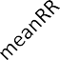





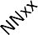


Figure 33 Comparison of Normalized mean Time domain feature values between two groups
Time domain
1.2
1
0.8
0.6
0.4
0.2
0

Features

Game With Game Without
Normalize Value
Figure 33 shows the effect of two games on heart rate variability (HRV) parameters. Time domain features are related to how much variation there is between consecutive heart beats. A natural calm response of the heart is characterized by higher values of HRV parameters. The physiological phenomenon behind this is explained by the control pf parasympathetic nervous system actions (PNS), which takes the body to a fight or flight mode, so it is better equipped to cope with stress. Although detail working this is beyond the domain of this thesis, we do know from literature that higher values of time domain features are preferred to cope with stress.
Figure 33 indicates that for most of the parameters, the Game with values are usually higher than the game without parameters. From physiological point of view, body was better equipped to deal with stress during ‘game with’.

Game With Game Without
Normalize Value

Figure 34 and 35 shows the High and low frequency parameters of the HRV respectively. Similar to time domain features, these values give information about the changes in consecutive heart beats. Here again a higher value indicated onset of PNS, so higher values during ‘game with’ suggest that game elements in this game can better condition the body to cope with stress.
Low frequency
1.2
1
0.8
0.6
0.4
0.2
0
peak
abspower logpower
Features
relpower
relpowerNU
Game With Game Without
Figure 34 Comparison of Normalized mean Frequency domain feature (Low frequency components) values between two groups
High Frequency
1.2
1
0.8
0.6
0.4
0.2
0
peak
abspower
logpower
Features
relpower
relpowerNU
Figure 35 Comparison of Normalized mean Frequency domain feature (High frequency
components) values between two groups
Normalize Value

Normalize Value

Figure 36 Comparison of Normalized NON-Linear feature values between two groups
Non linear
1.2
1
0.8
0.6
0.4
0.2
0
sd1
sd2
sdr
ApEn SaEn dfa1
dfa2
dfr
Features

Game With Game Without

Figure 36 are nonlinear parameters of the HRV. These results have mixed values, indicating that these parameters might not be a very good measures to study the effects of these games.
    - Statistical Test
The table below shows the results of the statistical test performed on the two groups. A two tailed, unpaired t-test was performed on both groups. First column of the table represents all those features which indicate that there exists a statistically significant difference between the two groups. A total of 18 features were significantly found to be different in the two groups.
The second column showed those features which did not change significantly between the two groups.
This study shows that it is possible to reduce mental stress by including game design factors in a game. This will reduce the stress that will both be observable in physiological signals of the subject, and statistical test that are performed on the results.
The results clearly show that the game implemented on proposed framework can help reduce, and manage stress. These 18 features indicate that there is a measurable difference in term of stress indicators and rest of the 11 features showed no measurable difference.

The results clearly show that the stress levels of the participants that played the SyncEscape game developed on framework with game design factors is lower than the participants who played SyncEscape game without game design factors.
In conclusion, results indicate that time-domain and frequency domain features are more suitable to study the effect of game elements in conditioning human body to cope with stress. Also we have shown that some elements in the game can better equip the body to cope with stress, thus reducing the risk of stress causing any harmful effects on the body.

P < 0.05 |  | P > 0.05
Feature | P-Value | Feature | P-Value
𝑃̅̅𝑃̅̅ | 0.00477051 | STD PPM | 0.06654753
SDPP | 0.00017761 | Maximum PPM | 0.29172206
Mean PPM | 0.00614580 | SD ratio | 0.52649090
Minimum PPM | 0.01937667 | ApEn | 0.14033833
RMSSD | 0.00020658 | SaEn | 0.0576591
NNxx | 0.00165677 | DFA α1 | 0.65365133
pNNxx | 0.0014305 | LF Peak Frequency | 0.95348505
PRV triangular index | 0.000961 | LF Norm*. Power | 0.43108126
TINN | 0.00043111 | HF Peak Frequency | 0.20903822
SD1 | 0.00038187 | HF Rel. power | 0.73347578
SD2 | 0.00056906 | HF Norm*. Power | 0.42984895
DFA α2 | 0.00142732
DFA ratio | 0.00404913
LF Abs. power | 0.00125419
LF Log power | 0.00033133
LF Rel. power | 0.03519379
HF Abs power | 0.00263896
HF log power | 0.00078954
    - Summary of this chapter
In this section, evaluation results were explained in detail. For framework, expert validation was conducted. The second evaluation two versions of the same game were developed, one had game design factors and other did not have game design factors. It was seen that the game with design factors was successful in lowering the stress of participants as compare to the participants who

played the second version of the game. It was concluded that our proposed serious games framework has the potential to be used in developing games for mental health domain.

Chapter 6: Conclusion and Discussion
This chapter lists down the research contribution of my research, limitations and future work that can be researched upon.

  - Conclusion

In this study, we proposed a framework to guide the game developers to develop serious games for human wellbeing. We considered game elements and efficient psychological interventions present in the literature to show the mapping between these game factors and principles of the theories.

  - Research Contributions

Our work contributes to the literature by:

- Identifying Psychological interventions and game design elements from the literature.

- Mapping psychological interventions which include Cognitive Behaviour theory and Behaviour change techniques to game design factors that include (Goal, interaction, immersion, autonomy, competence, feedback, reward and punishment).

- Developing a game with these game design factors to see the impact it has on stress levels of the player.

  - Limitations

The study conducted only targeted one mental health disorder, stress. The impact of the implemented game was not checked for other mental health disorders like anxiety. The game showed positive result in lowering stress levels as it included all the game design factors (Goal, Interaction, autonomy, immersion, competence, feedback, rewards and punishment), but individual effects that each game element has on physiological signals was not assessed.

  - Future Work

The SyncEscape game version 1, incorporated all the game elements present in the proposed framework, and it showed positive results. In future we can work on assessing the impact of each individual game element on the stress levels, in order to see which game elements have greater impact in reducing stress levels.

Another future direction that can be worked upon is assessing the compliance rate of patient with the therapeutic treatment being done with the help of mental health serious games, to see the if the patients have higher compliance rates or lower.

  - Discussion

Our findings suggest that the participants who played version 1 of the game, with game design factors experienced Lower stress levels than the participants who played version 2 of the game without game design factors. It was proved when 18 features showed statistical significance difference between the two groups hence rejecting our null hypothesis that there exist no difference between the stress levels of our both groups (With Game design factors Game, Version 1 and Without Game design factors Game, Version 2 ).

References
- P. Lankoski, Game Research Methods: An Overview. 2015.
- “A Brief History of Serious Games,” ResearchGate. [Online]. Available: https://www.researchgate.net/publication/308902377_A_Brief_History_of_Serious_Games. [Accessed: 18-Mar-2019].
- A. V. Kamasheva, E. R. Valeev, R. K. Yagudin, and K. R. Maksimova, “Usage of Gamification Theory for Increase Motivation of Employees,” Mediterr. J. Soc. Sci., vol. 6, no. 1 S3, p. 77, Feb. 2015.
- A. Baum, “Stress, intrusive imagery, and chronic distress.,” Health Psychol., vol. 9, no. 6,
pp. 653–675, 1990, doi: 10.1037/0278-6133.9.6.653.
- H. Selye, The stress of life. New York, NY, US: McGraw-Hill, 1956.
- B. Stokes, “Videogames have changed: time to consider ‘Serious Games’?,” Dev. Educ. J., vol. 11, p. 12, Jan. 2005.
- V. Wattanasoontorn, I. Boada, R. García, and M. Sbert, “Serious games for health,” Entertain. Comput., vol. 4, no. 4, pp. 231–247, Dec. 2013, doi: 10.1016/j.entcom.2013.09.002.
- N. Khalili-Mahani and B. De Schutter, “Affective Game Planning for Health Applications: Quantitative Extension of Gerontoludic Design Based on the Appraisal Theory of Stress and Coping,” JMIR Serious Games, vol. 7, no. 2, p. e13303, Jun. 2019, doi: 10.2196/13303.
- D. Johnson, S. Deterding, K.-A. Kuhn, A. Staneva, S. Stoyanov, and L. Hides, “Gamification for health and wellbeing: A systematic review of the literature,” Internet Interv., vol. 6, pp. 89–106, Nov. 2016, doi: 10.1016/j.invent.2016.10.002.
- S. Mader, G. Levieux, and S. Natkin, “A Game Design Method for Therapeutic Games,” in 2016 8th International Conference on Games and Virtual Worlds for Serious Applications (VS-GAMES), 2016, pp. 1–8, doi: 10.1109/VS-GAMES.2016.7590333.
- N. Yusof, R. Mohd rias, and E. Yusoff, “Embedding Cognitive Behavior Therapy in Therapeutic Game Design Model for Depression,” J. Converg. Inf. Technol., vol. 10, pp. 1– 11, Sep. 2015.
- A. F. A. de Vette, M. Tabak, and M. M. R. Vollenbroek-Hutten, “How to Design Game- based Healthcare Applications for Children? - A Study on Children’s Game Preferences,” presented at the 11th International Conference on Health Informatics 2018, 2018, doi: 10.5220/0006584804220430.
- H. Kharrazi, A. Faiola, and J. Defazio, “Healthcare Game Design: Behavioral Modeling of Serious Gaming Design for Children with Chronic Diseases,” in HCI, 2009, doi: 10.1007/978-3-642-02583-9_37.
- C. Cheek et al., “Integrating Health Behavior Theory and Design Elements in Serious Games,” JMIR Ment. Health, vol. 2, no. 2, p. e11, Jun. 2015, doi: 10.2196/mental.4133.
- H. Kharrazi, A. Faiola, and J. Defazio, “Healthcare Game Design: Behavioral Modeling of Serious Gaming Design for Children with Chronic Diseases,” in HCI, 2009, doi: 10.1007/978-3-642-02583-9_37.
- E. J. Lyons, Z. H. Lewis, B. G. Mayrsohn, and J. L. Rowland, “Behavior Change Techniques Implemented in Electronic Lifestyle Activity Monitors: A Systematic Content Analysis,” J. Med. Internet Res., vol. 16, no. 8, Aug. 2014, doi: 10.2196/jmir.3469.

- S. Michie et al., “The behavior change technique taxonomy (v1) of 93 hierarchically clustered techniques: building an international consensus for the reporting of behavior change interventions,” Ann. Behav. Med. Publ. Soc. Behav. Med., vol. 46, no. 1, pp. 81–95, Aug. 2013, doi: 10.1007/s12160-013-9486-6.
- V. Visch, N. Vegt, H. Anderiesen, and K. van der kooij, “Persuasive Game Design: A model and its definitions,” 2013.
- T. Malone and M. Lepper, “Making learning fun: A taxonomy of intrinsic motivations for learning,” Mak. Learn. Fun Taxon. Intrinsic Motiv. Learn., vol. 3, Jan. 2005.
- Y.-R. Shi and J.-L. Shih, “Game Factors and Game-Based Learning Design Model,” Int.
J. Comput. Games Technol., vol. 2015, pp. 1–11, Aug. 2015, doi: 10.1155/2015/549684.
- W. Jin, D. Gromala, and X. Tong, “Serious game for serious disease: Diminishing stigma of depression via game experience,” in 2015 IEEE Games Entertainment Media Conference (GEM), 2015, pp. 1–2, doi: 10.1109/GEM.2015.7377256.
- A. A. Shalaby and N. Barakat, “Mission Possible: A Gamified Approach to Handle Cancer Survivors Stress,” in 2017 European Conference on Electrical Engineering and Computer Science (EECS), 2017, pp. 52–55, doi: 10.1109/EECS.2017.19.
- J. A. Piedra-Fernandez, A. J. Cangas, J. J. Ojeda-Castelo, D. Cangas, and A. J.
Fernandez-Garcia, “Stigma-Stop a Serious Game against the Stigma in Mental Disorders,” in 2016 8th International Conference on Games and Virtual Worlds for Serious Applications (VS-GAMES), 2016, pp. 1–4, doi: 10.1109/VS-GAMES.2016.7590367.
- J. Li, Y.-L. Theng, and S. Foo, “Game-Based Digital Interventions for Depression Therapy: A Systematic Review and Meta-Analysis,” Cyberpsychology Behav. Soc. Netw., vol. 17, no. 8, pp. 519–527, Aug. 2014, doi: 10.1089/cyber.2013.0481.
- A. Szczesna, J. Grudzinski, T. Grudzinski, R. Mikuszewski, and A. Debowski, “The psychology serious game prototype for preschool children,” in 2011 IEEE 1st International Conference on Serious Games and Applications for Health (SeGAH), 2011, pp. 1–4, doi: 10.1109/SeGAH.2011.6165435.
- Á. Tóth and S. Tóvölgyi, “The introduction of gamification: A review paper about the applied gamification in the smartphone applications,” in 2016 7th IEEE International Conference on Cognitive Infocommunications (CogInfoCom), 2016, pp. 000213–000218, doi: 10.1109/CogInfoCom.2016.7804551.
- K. Starks, “Cognitive behavioral game design: a unified model for designing serious games,” Front. Psychol., vol. 5, 2014, doi: 10.3389/fpsyg.2014.00028.
- D. Thompson, T. Baranowski, and R. Buday, “Conceptual Model for the Design of a Serious Video Game Promoting Self-Management among Youth with Type 1 Diabetes,” J. Diabetes Sci. Technol., vol. 4, pp. 744–9, May 2010, doi: 10.1177/193229681000400331.
- N. Yusof and R. M. Rias, “Serious game based therapeutic: Towards therapeutic game design model for adolescence,” in 2014 IEEE Conference on e-Learning, e-Management and e-Services (IC3e), 2014, pp. 40–45, doi: 10.1109/IC3e.2014.7081239.
- S. S. Shagiwal, A. Schop-Etman, I. Bergwerff, W. Vrencken, and S. Denktaş, “The BeHealthyR Study: a randomized trial of a multicomponent intervention to reduce stress, smoking and improve financial health of low-income residents in Rotterdam,” BMC Public Health, vol. 18, no. 1, p. 891, 18 2018, doi: 10.1186/s12889-018-5728-7.
- M. Willett, J. Duda, S. Fenton, C. Gautrey, C. Greig, and A. Rushton, “Effectiveness of behaviour change techniques in physiotherapy interventions to promote physical activity

adherence in lower limb osteoarthritis patients: A systematic review,” PloS One, vol. 14, no. 7, p. e0219482, 2019, doi: 10.1371/journal.pone.0219482.
- S. Michie, C. Abraham, C. Whittington, J. McAteer, and S. Gupta, “Effective techniques in healthy eating and physical activity interventions: a meta-regression,” Health Psychol. Off.
J. Div. Health Psychol. Am. Psychol. Assoc., vol. 28, no. 6, pp. 690–701, Nov. 2009, doi: 10.1037/a0016136.
- E. Rahmani and S. A. Boren, “Videogames and Health Improvement: A Literature Review of Randomized Controlled Trials,” Games Health J., vol. 1, no. 5, pp. 331–341, Oct. 2012, doi: 10.1089/g4h.2012.0031.
- C. Abraham and S. Michie, “A taxonomy of behavior change techniques used in interventions,” Health Psychol. Off. J. Div. Health Psychol. Am. Psychol. Assoc., vol. 27, no. 3, pp. 379–387, May 2008, doi: 10.1037/0278-6133.27.3.379.
- J. Proudfoot et al., “Clinical efficacy of computerised cognitive-behavioural therapy for anxiety and depression in primary care: randomised controlled trial,” Br. J. Psychiatry J. Ment. Sci., vol. 185, pp. 46–54, Jul. 2004, doi: 10.1192/bjp.185.1.46.
- J. H. Wright, “Cognitive Behavior Therapy: Basic Principles and Recent Advances,”
FOCUS, vol. 4, no. 2, pp. 173–178, Apr. 2006, doi: 10.1176/foc.4.2.173.
- F. M. Dattilio and M. A. Hanna, “Collaboration in cognitive-behavioral therapy,” J. Clin. Psychol., vol. 68, no. 2, pp. 146–158, Feb. 2012, doi: 10.1002/jclp.21831.
- C. Weitze, “Developing Goals and Objectives for Gameplay and Learning,” 2014, pp. 225–249.
- C. Burgers, A. Eden, M. Engelenburg, and S. Buningh, “How feedback boosts motivation and play in a brain-training game,” Comput. Hum. Behav., vol. 48, pp. 94–103, Jul. 2015, doi: 10.1016/j.chb.2015.01.038.
- “The Motivational Pull of Video Games: A Self-Determination Theory Approach | SpringerLink.” [Online]. Available: https://link.springer.com/article/10.1007/s11031-006- 9051-8. [Accessed: 27-Dec-2019].
- K. Salen and E. Zimmerman, “Rules of Play : Game Design Fundamentals / K. Salen, E. Zimmerman ; pról. de Frank Lantz.,” Jan. 2004.
- G. A. van Mastrigt, A. T. Paulus, M.-J. Aarts, S. M. Evers, and A. F. Alayli-Goebbels, “A qualitative study on the views of experts regarding the incorporation of non-health outcomes into the economic evaluations of public health interventions,” BMC Public Health, vol. 15, no. 1, p. 954, Sep. 2015, doi: 10.1186/s12889-015-2247-7.
- N. Mays and C. Pope, “Rigour and qualitative research,” BMJ, vol. 311, no. 6997, pp. 109–112, Jul. 1995, doi: 10.1136/bmj.311.6997.109.
- K. Lasch et al., “PRO development: Rigorous qualitative research as the crucial foundation,” Qual. Life Res. Int. J. Qual. Life Asp. Treat. Care Rehabil., vol. 19, pp. 1087– 96, Oct. 2010, doi: 10.1007/s11136-010-9677-6.
- E. J. Feeney, “Performance standards, feedback, and rewards: A performance improvement system,” Natl. Product. Rev., vol. 2, no. 1, pp. 36–42, 1982, doi: 10.1002/npr.4040020107.
- S. Mayya, V. Jilla, V. N. Tiwari, M. M. Nayak, and R. Narayanan, “Continuous monitoring of stress on smartphone using heart rate variability,” in 2015 IEEE 15th International Conference on Bioinformatics and Bioengineering (BIBE), 2015, pp. 1–5, doi: 10.1109/BIBE.2015.7367627.

- T. Hao, K. N. Walter, M. J. Ball, H.-Y. Chang, S. Sun, and X. Zhu, “StressHacker: Towards Practical Stress Monitoring in the Wild with Smartwatches,” AMIA. Annu. Symp. Proc., vol. 2017, pp. 830–838, Apr. 2018.
- “The flow experience and its significance for human psychology | Semantic Scholar.” [Online]. Available: https://www.semanticscholar.org/paper/The-flow-experience-and-its- significance-for-human- Cs%C3%ADkszentmih%C3%A1lyi/0fef4cbe4c1b7b6312383d2cdccf93f195fcc5bc. [Accessed: 08-Dec-2019].
- M. Deen, “G.A.M.E. Games Autonomy Motivation & Education: How autonomy- supportive game design may improve motivation to learn,” 2015.
- A. Cantara and A. Ceniza, “Stress Sensor Prototype: Determining the Stress Level in using a Computer through Validated Self-Made Heart Rate (HR) and Galvanic Skin Response (GSR) Sensors and Fuzzy Logic Algorithm,” Int. J. Eng. Res. Technol., vol. 5, pp. 28–37, Mar. 2016.
- H.-G. Kim, E.-J. Cheon, D.-S. Bai, Y. H. Lee, and B.-H. Koo, “Stress and Heart Rate Variability: A Meta-Analysis and Review of the Literature,” Psychiatry Investig., vol. 15, no. 3, pp. 235–245, Mar. 2018, doi: 10.30773/pi.2017.08.17.
- K. Fenn and M. Byrne, “The key principles of cognitive behavioural therapy,” InnovAiT, vol. 6, no. 9, pp. 579–585, Sep. 2013, doi: 10.1177/1755738012471029.

Appendix
Appendix A: Survey Questions
Thesis Evaluation
This questionnaire is a part of a Serious Game Framework for Mental Health thesis evaluation conducting at FAST NUCES under the supervision of Dr. Arshad Ali Shahid. We have proposed a framework to design serious games for human wellbeing. We have mapped psychological theories of Behavior Change theory and Behavior change technique to game elements to design games that can help in overcoming mental disorders of stress & anxiety.

All collected data will be analyzed anonymously and will be distributed/ communicated only in aggregated form in thesis report. If you would like to receive the analysis, please leave your email at the end of the questionnaire. Your time and interest is highly regarded.

We appreciate your time and support!
* Required

- Do you think Game design factors can add more value to the game? *
Game design Factors include game goals, game mechanism, game fantasy, game value, interaction, freedom, narrative, sensation, challenges, sociality, and mystery.
  - Strongly Agree
  - Agree
  - Undecided
  - Disagree
  - Strongly Disagree

- Do you think that Psychological Therapies of Cognitive behavior theory (CBT) and Behavior change technique (BCT) can be used when designing games for mental health? *
- CBT is how a person thinks (cognition), how he feels (emotion) and how he acts (behavior) all interact together. Behavior change techniques are coordinated sets of activities designed to change specified behavior patterns.
  - Strongly Agree
  - Agree
  - Undecided
  - Disagree
  - Strongly Disagree
- Do you think game design elements with CBT and BCT principles can help in being more effective in treatment of a person? *
  - Strongly Agree
  - Agree
  - Undecided
  - Disagree
  - Strongly Disagree
- Do you think a person can be educated about handling stress through game elements? *
  - Strongly Agree
  - Agree
  - Undecided
  - Disagree
  - Strongly Disagree
- Do you think that Game Goals inspire a person to set his goals in real life? *
  - Strongly Agree
  - Agree
  - Undecided
  - Disgaree
  - Strongly Disagree

- Do you think challenging the negative thoughts of a person can be done through the game "Challenges" in the game world? *
  - Strongly Agree
  - Agree
  - Undecided
  - Disagree
  - Strongly Disagree
- Do you think "Feedback" is effective for a person to be used while treatment? *
  - Strongly Agree
  - Agree
  - Undecided
  - Disagree
  - Strongly Disagree
- Should "Continuous monitoring" be done to provide "Feedback" to players in the game? *
  - Strongly Agree
  - Agree
  - Undecided
  - Disagree
  - Strongly Disagree
- Is "Feedback" necessary for every challenge a person takes in a game? *
  - Strongly Agree
  - Agree
  - Undecided
  - Disagree
  - Strongly Disagree
- Do you think "Social Interaction" (Collaboration)in games can help a person to improve his mental health and lower stress Levels? *
  - Strongly Agree
  - Agree
  - Undecided

  - Disagree
  - Strongly Disagree
- Do the game elements of "Reward and Punishment" have positive effect on a person outcome? *
  - Strongly Agree
  - Agree
  - Undecided
  - Disagree
  - Strongly Disagree
- Do you think "Immersion" can bring real experience into the game word? * Immersion is a deep mental involvement in an activity or game. It includes factors like Enjoyment, Involvement and Fun.
  - Strongly Agree
  - Agree
  - Undecided
  - Disagree
  - Strongly Disagree
- Do you think by "Immersion" a player can own his problem and work on them? *
Immersion is a deep mental involvement in an activity or game
  - Strongly Agree
  - Agree
  - Undecided
  - Disagree
  - Strongly Disagree
- Do you think "Challenges" in a game make player feels safe in such environment where he can view his potentials and stress levels?
  - Strongly Agree
  - Agree
  - Undecided
  - Disagree
  - Strongly Disagree

- Do you think "Autonomy" is important factor to be considered for enhancing treatment outcome?
- Autonomy is a person's perception that they have the ability to act however they choose.
  - Strongly Agree
  - Agree
  - Undecided
  - Disagree
  - Strongly Disagree
- Suggestions

Appendix B: Introduction Script
Assalam-o-Alaikum! My name is Tehreem Shabbir and I’ll be interviewing you today. You probably already have a good idea of why I have taken an appointment from you but let me go over it again briefly that I am going to be walking you through this session in order to understand about the treatments being applied on patients who suffer from mental disorders. As an interviewee I value your opinions and insights. This session will going to take about 30 minutes and during this session I will be going to ask you several questions about “What are the treatments/therapies that are being practiced with patients”. First thing that I want to make clear is that I am not here to judge you; I am just here only to know the current practices in the field of psychology. If it is okay with you, I will be tape-recording our conversation. The purpose of this is so that I can get all the details but at the same time be able to carry on an attentive conversation with you. I assure you that all your comments will remain confidential. If I quote you in my thesis final report, I will first ask your permission and if you do not agree I will do so without identifying your name. I would like you to feel comfortable with saying what you really think and how you really feel. Also, this interview is totally voluntary on your part if for any reason you want to stop, please let us know.
Do you have any questions so far? Are you ready to start?

Questions:

- What are the common mental health disorders that your patients suffer from?

- What kind of treatment and therapies are given to them?
- Have they ever used any other application or game to overcome their stress?
- Since when are you practicing?
- How many patients do you get who suffer from stress in daily routine?
- Your patients are mostly male or female?
- Do you believe that by introducing technology you can enhance the outcome/result of patient’s progress?
- Do your ever recommend your patients some applications or games to use?
- If yes then, what are the common applications that you usually recommend?
- Can you tell me the features of those applications?
  - What is the effect of that feature on stress/anxiety?
- Have these applications/games implemented any psychological intervention in them?
  - What are the theories/therapies implemented in them?
- How do you treat your patients?
- What are the psychological theories used in treatments?
- What are the common elements present in them?
- What are the techniques that you tell your patients to try to release stress?
- What roles does psychoeducation play in treatments?
- Do you think CBT is a good approach in treatment?
  - What are the main principles on which CBT relies?
  - How does it improve the patients stress levels?
- Do you think stress can be handled by applying behavior change techniques?
- Do you think getting high scores in a game can improve patient outcome?
- What is your observation of patients, do they feel motivated by games rewards system like, badges?
Okay that was very helpful. Those are all the questions we have for you. Thank you for your time. It really matters to me. I may be in touch with you again to ask a few follow up questions or if I need any other details regarding the solution I am developing.
Do you have any questions? Thanks again!

